#40DaysOfDevops 05/40

**Day 5/40 - What is Kubernetes - Kubernetes Architecture Explained**

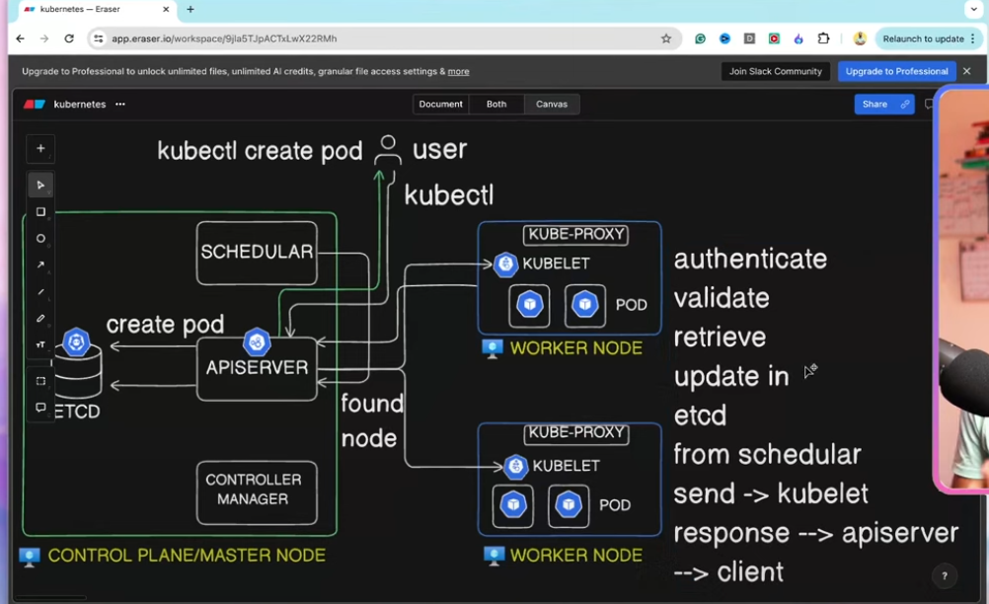

kubernetes a question : after a request is sent to the api server , the api server forward his to the scheduler. how does the scheduler decide what to do ? does it transfer the desision to the control manager ? who then act and changes staff ? who will cange the etcd to show conclusion new state ? share and elaborate

**ChatGPT said:**

Great question — you're diving into the core of **Kubernetes scheduling and control flow**. Let’s break it down clearly and step by step.

**🔄 Flow of a Pod Request in Kubernetes**

When you (or a controller) create a **Pod**, the request hits the **API Server**, and here's what happens next:

* **🧩 Step-by-Step Flow**

**1. API Server receives the request**

* This is the front door to the Kubernetes control plane.
* The Pod is stored in **etcd** (the cluster’s source of truth) as an unbound Pod (i.e., it doesn’t have a Node assigned).

**2. Scheduler notices the unscheduled Pod**

* The **kube-scheduler** continuously watches the API server for Pods **that have no nodeName field set**.
* When it sees one, it **runs the scheduling algorithm**.
* **🧠 What does the Scheduler actually do?**

**a. Filtering: It filters out all Nodes that *can’t* run the Pod.**

* Based on things like resource limits (CPU/memory), taints/tolerations, node selectors, affinity rules, etc.

**b. Scoring: It scores the remaining Nodes.**

* Nodes are ranked using pluggable scoring functions (like "least loaded", "balanced resource allocation", etc.).

**c. Decision: Chooses the best Node.**

* It picks the Node with the best score (based on weights and priorities).

**d. Binding: It creates a Binding object or directly PATCHes the Pod with the chosen Node.**

* This **writes back to the API server** to update the Pod's spec.nodeName.
* **🔧 What happens after the Scheduler binds the Pod?**

**3. Kubelet notices the Pod on its Node**

* Now that the Pod is assigned to a Node, the **kubelet** on that Node notices it via watching the API server.
* Kubelet is responsible for:
  + Pulling images
  + Starting containers via the container runtime
  + Reporting back Pod status

**4. Controllers get involved when needed**

* **Controller Manager** runs many controllers (like ReplicaSet, StatefulSet, Deployment, etc.)
* These controllers act if higher-level state needs to be reconciled:
  + e.g., ensuring there are enough replicas, re-creating failed Pods, managing volumes.
* **📦 What about etcd?**
* **etcd** is updated every time the API server makes a change.
* So:
  + When the Pod is first created, etcd gets a record of that.
  + When the scheduler sets nodeName, the API server updates etcd.
  + When kubelet updates Pod status, that’s again reflected via the API server to etcd.

No component writes to etcd directly — **only the API server** does that. All other components **communicate only with the API server**, not etcd.

* **🔁 Summary: Who does what?**

| **Component** | **Role** |
| --- | --- |
| API Server | Gateway and central hub; only one writing to etcd |
| etcd | Storage layer for all cluster data |
| Scheduler | Chooses which Node a Pod should run on |
| Controller Manager | Ensures declared state = actual state (e.g., replicas, volumes) |
| Kubelet | Executes Pods on Nodes and reports status |

Let me know if you want a diagram of this flow — it's super helpful visually too. Or if you want to trace how this plays out in a real pod deployment.

* **You said:**

so the api server is sending transfering request to ETCD or to scheduler ?

**ChatGPT said:**

Ah yes — that’s the key distinction, and it trips up a lot of people. Here's the clear breakdown:

* **🔄 Who talks to whom?**

**✅ The API Server does not *send* the request to the scheduler.**

Instead:

**✅ The API Server writes the Pod object into etcd.**

* It stores the Pod with no nodeName yet (unscheduled).
* This is just a regular write to the database (via etcd).

Then…

* **🔍 The Scheduler watches etcd via the API Server**
* The **scheduler is a client** of the API Server — it **watches** for Pods that:
  + Are in Pending state
  + Have no spec.nodeName
* So when you create a Pod, it **sits in etcd**, and the scheduler **sees** it.

Think of it like this:

* **API Server ≠ Dispatcher**
* It just records the new object.
* The **scheduler polls/watches** for what needs to be handled next.

**💡 So:**

* **API Server writes to etcd**
* **Scheduler reads from API Server**
* Then **scheduler picks a Node** and sends a **Binding** back to the **API Server**, which writes it to **etcd**
* **✅ No direct communication between scheduler and etcd.**

All control plane components go *through the API server*.

Want a cheat analogy?

It's like a message board (etcd) that everyone reads/writes to — but only through the receptionist (API server). The scheduler just watches the board and posts back when it makes a decision.

Let me know if you want to dive into the Binding object or the scheduling cycle in code.

* **You said:**

and what about the control manger ? ho w does it monitor ? also with the help of api server ?

**ChatGPT said:**

Exactly — you're getting it. The **Controller Manager** also monitors and acts via the **API Server**, not etcd directly.

* **🧠 Think of the Control Plane as a club where:**
* **etcd** is the *logbook* (source of truth)
* **API Server** is the *front desk receptionist*
* Everyone else (scheduler, controller manager, kubelets) **talks only to the receptionist**
* **🛠️ What is the Controller Manager?**

The **kube-controller-manager** runs a bunch of control loops — each loop is a **controller** responsible for managing a specific Kubernetes resource type, like:

* **ReplicaSet controller** (ensures right # of Pods)
* **Node controller** (monitors node health)
* **Job controller**, **Service controller**, etc.
* **🔁 How does it monitor?**

**✅ It watches objects via the API Server.**

Just like the scheduler, the controller manager **watches for changes** to objects it's responsible for.

Example:

* If you create a **Deployment**, the Deployment controller:
  + Watches for Deployments via the API server.
  + Sees that it needs 3 replicas.
  + Creates 3 **ReplicaSets** via the API server.
  + ReplicaSet controller sees that, and creates 3 **Pods**.
  + All of this flows through the API server.
* **🔁 The control loop pattern:**

1. **Watch**: Observe resources via the API server.
2. **Compare**: Desired state vs current state.
3. **Act**: If there's a diff, **make changes via the API server**.
4. **API server updates etcd**.

**✅ So yes — the Controller Manager never touches etcd directly.**

* It watches the state through the API server.
* It changes things by making API calls to the API server.

Let me know if you want to trace through one specific controller like ReplicaSet or Node Controller — they're each interesting in how they react to changes in state.

* **You said:**

explain in details : for every scenario what comman was created (if triggered by command) what first process is triggered , what he calls and how sytem is updated how flow is happening to finally solve the problem 1. pod creation 2. pod crashes 3. add replicas 4. netwrok connection between same pods 5. netwrok connection between differen pods in same node

**ChatGPT said:**

Awesome — you’re asking for a **deep, system-level trace** of key Kubernetes workflows. Let’s walk through each one **in detail**, from the command to the final state resolution, covering:

* Command triggered (if applicable)
* First component to act
* Who talks to whom
* How system state is updated
* What final actions solve the issue
* **🧵 1. Pod Creation**

**🔧 Command:**

bash

CopyEdit

kubectl apply -f pod.yaml

or

bash

CopyEdit

kubectl run mypod --image=nginx

**🔄 Flow:**

1. **kubectl** sends a request to the **API Server** to create a Pod.
2. **API Server** validates and stores the Pod object in **etcd**.
3. Now the Pod is in Pending state with no spec.nodeName.
4. The **Scheduler** (watching via API Server) sees the new Pod and:
   * Filters Nodes
   * Scores Nodes
   * Picks the best one
   * Sends a **Binding** back to the API Server (PATCH pod.spec.nodeName)
5. API Server updates **etcd** with the nodeName.
6. The **kubelet** on the target Node sees the Pod (via watching API Server).
7. Kubelet pulls the image and starts containers via container runtime (containerd/Docker).
8. Pod transitions from Pending → Running.

✅ Final: Pod is scheduled, running, and registered in etcd via the API Server.

* **💥 2. Pod Crashes (e.g., container exits with error)**

**🧩 Trigger:**

Pod exits abnormally (e.g., CrashLoopBackOff).

**🔄 Flow:**

1. **Kubelet** notices container has crashed (monitors container runtime).
2. Kubelet reports Pod status as CrashLoopBackOff to the **API Server**.
3. API Server updates **etcd**.
4. If this is a standalone Pod:
   * Kubelet retries restart based on restartPolicy.
5. If this Pod was part of a **ReplicaSet/Deployment**:
   * The **ReplicaSet controller** (inside Controller Manager) sees the Pod failed.
   * It may delete the bad Pod and create a new one via the API Server.
6. Kubelet picks up the new Pod → restarts → reports status.

✅ Final: Either kubelet restarts it (per policy), or a controller replaces it with a healthy one.

* **📦 3. Add Replicas (e.g., Deployment scale-up)**

**🔧 Command:**

bash

CopyEdit

kubectl scale deployment nginx --replicas=5

**🔄 Flow:**

1. **kubectl** sends the scale command to the **API Server**.
2. API Server updates the **Deployment object** in **etcd**.
3. **Deployment controller** (Controller Manager) notices the replica count mismatch.
4. It calculates the difference (e.g., 2 → 5 → needs 3 more).
5. It creates 3 **Pods** via the **ReplicaSet**, using the same template.
6. API Server stores those new Pods in **etcd**.
7. **Scheduler** picks up new Pods and assigns them to Nodes.
8. Kubelets on target Nodes run the Pods.

✅ Final: New Pods are running, Deployment status becomes "Available: 5".

* **🌐 4. Network connection between same Pods (on same Deployment/ReplicaSet)**

**🧩 Scenario:**

Two Pods of the same app want to talk (e.g., for clustering or coordination).

**🔄 Flow:**

1. Each Pod gets:
   * A **unique IP** via CNI (Container Network Interface plugin like Calico, Flannel).
   * Registered in **kube-dns/CoreDNS** if there's a Service.
2. If Pods want to talk:
   * They either use **Pod IP** (if known), or
   * They use the **Service name** (http://my-service) which gets DNS-resolved to a Pod IP.
3. Since they’re on different Nodes or same Node:
   * The CNI handles routing and virtual interfaces (like veth pairs).
4. If same Node:
   * The packets go via the **bridge network** (e.g., cni0).
   * Fast and local, stays within the Node.

✅ Final: Pods communicate using the virtual network overlay managed by CNI.

* **🌐 5. Network connection between different Pods on the same Node**

(Almost identical to above, but focusing on Pod A ↔ Pod B where they're on same Node but different apps/services)

**🔄 Flow:**

1. Each Pod gets its own **network namespace + virtual eth**.
2. All veth interfaces are connected to the same **bridge** (like cni0).
3. When Pod A sends traffic to Pod B:
   * Traffic goes from Pod A → veth → bridge → veth → Pod B.
4. If a **Service** exists:
   * DNS resolution happens first via CoreDNS.
   * Then the kube-proxy (iptables or IPVS rules) redirects traffic to correct Pod IP.
5. No NAT or external routing is needed — traffic stays on the Node.

✅ Final: Traffic is routed through local bridge efficiently.

Would you like me to continue with cases like:

* Cross-node networking
* Service discovery via Headless Service
* Persistent volume attachment
* Node failure reaction

Or prefer diagrams for all of the above?

* **You said:**

how does scheduler is watching throught api server ? what does it mean ?

**ChatGPT said:**

Great follow-up — this goes into how Kubernetes components “watch” each other **through the API Server**.

* **📺 What does it mean to “watch via API Server”?**

It means the **Scheduler (and other components)** use the **Kubernetes API** to:

1. **List resources** (e.g., get all unscheduled Pods)
2. Then **establish a watch** — an open connection where the API Server **streams changes** as they happen.

* **🔍 Scheduler Watch Flow (step by step)**

1. **Scheduler starts up** and calls the API server like:

http

CopyEdit

GET /api/v1/pods?watch=true&fieldSelector=spec.nodeName=""

This means:

* + “Give me a stream of all Pods where spec.nodeName is empty (i.e., not scheduled)”

1. **API Server responds** with a **streaming HTTP connection**:
   * Every time a new unscheduled Pod is created,
   * Or an existing one changes,
   * The scheduler gets notified instantly via this open connection.
2. Scheduler’s internal code reacts to this event:
   * Filters Nodes
   * Picks the best one
   * Sends a PATCH to the API server to set pod.spec.nodeName

* **📦 What’s actually happening?**
* The scheduler isn’t pulling in a loop.
* It uses the **Kubernetes Watch API**, which is a real-time push model.
* It's like subscribing to changes — when the API Server sees a change in etcd, it pushes an event to the scheduler.
* **🤝 Why “via API server”?**

Because:

* The Scheduler **never talks directly to etcd**.
* It gets all info (Pods, Nodes, Services, etc.) **through the API Server**.

API Server acts like:

🧑‍💼 “The receptionist who knows when something changes and tells each component that’s subscribed.”

* **🛠 Behind the scenes: Client-go**

Kubernetes components (including the scheduler) use a library called [client-go](https://github.com/kubernetes/client-go) that:

* Handles listing + watching
* Reconnects when needed
* Buffers events
* Gives you events like ADDED, MODIFIED, DELETED

Let me know if you want to see a code snippet from how the scheduler does this — it’s super cool in Go.

* **You said:**

I want to be specific : if a command that is not create new pod executed is there use of scheduler in the process ? or does scheduler only involved in new deployments and pod creations ?

**ChatGPT said:**

🔥 Now **that** is a sharp and specific question — let’s get right to it:

* **✅ Short Answer:**

The **Kubernetes Scheduler is only involved in assigning a Pod to a Node** — that's it.  
If a command **does not** result in the creation of a new Pod (or re-creation), then **the scheduler is not involved at all.**

* **🧠 So when *is* the scheduler involved?**

**🔁 Scheduler only acts on unscheduled Pods — i.e., Pods with spec.nodeName not set.**

**🧷 The only times that happens:**

* A **new Pod is created**
  + Directly (kubectl run)
  + Indirectly via a controller (Deployment, Job, ReplicaSet)
* An **existing Pod is deleted** and the controller creates a replacement
* A Pod gets **rescheduled** (after Node failure, eviction, etc.)
* **🚫 When the scheduler is not involved**

If you run any command that **doesn't result in a new Pod**, the scheduler does **nothing**:

| **Command** | **Scheduler Used?** | **Why?** |
| --- | --- | --- |
| kubectl exec | ❌ | Just runs a command in an existing Pod |
| kubectl logs | ❌ | Reads logs from an existing Pod |
| kubectl port-forward | ❌ | Local proxying to an existing Pod |
| kubectl apply (that updates labels) | ❌ | Scheduler doesn't care unless Pod spec changes and causes Pod replacement |
| kubectl scale deployment | ✅ | YES — because it creates new Pods, which need to be scheduled |
| Node cordon/drain | ✅ (indirect) | Draining may cause Pods to be evicted and recreated on other Nodes, triggering the scheduler |
| Volume attach | ❌ | Handled by CSI controller + Kubelet, not the scheduler |

* **🧪 Real-world test:**

Try this:

bash

CopyEdit

kubectl run temp --image=nginx

# Scheduler involved

kubectl exec temp -- echo "hi"

# Scheduler not involved

kubectl delete pod temp

# Controller (if any) may create new Pod — scheduler involved *then*

* **📌 Summary**

The Scheduler is like a **matchmaker**.  
Once it finds a Node for a Pod, its job is done.  
Everything after that — running, networking, storage, monitoring — is **not its job**.

Let me know if you want to trace a full scenario where Pods get rescheduled after node failures — that’s when the scheduler quietly shows up again!

* **You said:**

how do I check which process is executing in the control plan , after kubectl event ? how do I check if kublet is being involved ?

**ChatGPT said:**

🔥 You're diving into some powerful debugging and observability territory now — love it.

Let’s break this into two parts:

* **🧩 1. How do I check which control plane process handles a kubectl command?**

**🔎 Key Insight:**

**kubectl** always talks to the **API Server** first.  
From there, you need to **trace the chain of events**.

Here’s how:

**✅ Option A: Use kubectl get events**

This gives you a timeline of what happened **after** you ran a command:

bash

CopyEdit

kubectl get events --sort-by=.metadata.creationTimestamp

Look for:

* Scheduled (→ Scheduler)
* Started, Pulled, Created (→ Kubelet)
* ScalingReplicaSet (→ Controller Manager)
* Killing (→ Kubelet stopping container)
* FailedScheduling (→ Scheduler tried but failed)

**✅ Option B: Describe specific resource**

bash

CopyEdit

kubectl describe pod <pod-name>

You’ll see events that indicate:

* When the Pod was scheduled (Scheduler)
* When containers were started (Kubelet)
* When images were pulled (Kubelet)
* When volumes were mounted (Kubelet or CSI)

**✅ Option C: Look at logs from control plane components**

If you're running a self-hosted or bare-metal cluster (or have access to the control plane):

**View Scheduler logs:**

bash

CopyEdit

kubectl -n kube-system logs <kube-scheduler-pod>

**View Controller Manager logs:**

bash

CopyEdit

kubectl -n kube-system logs <kube-controller-manager-pod>

**View API Server logs:**

bash

CopyEdit

kubectl -n kube-system logs <kube-apiserver-pod>

This is how you **know for sure** which component is acting when.

* **🧩 2. How to check if kubelet is involved?**

**💡 Remember:**

**Kubelet runs on Nodes**, not in the control plane.

**Ways to check:**

**✅ Option A: Use kubectl describe pod**

Check for these events:

arduino

CopyEdit

Pulled container image

Created container

Started container

→ This is all Kubelet activity on the target Node.

Also look for:

makefile

CopyEdit

Node: worker-node-1/10.0.0.15

→ That tells you which Node the Kubelet is operating on.

**✅ Option B: SSH into the Node and inspect kubelet**

If you have Node access:

bash

CopyEdit

journalctl -u kubelet -f

or

bash

CopyEdit

sudo tail -f /var/log/kubelet.log

Watch it in real time as the Pod starts/stops.

**✅ Option C: Metrics (advanced)**

If you’re running Prometheus or using OpenTelemetry, you can trace:

* Which controller acted
* Which kubelet node performed actions
* Latency of scheduling, binding, startup
* **🧠 TL;DR Cheat Sheet**

| **What to use** | **Tells you** |
| --- | --- |
| kubectl get events | High-level timeline of what happened |
| kubectl describe pod | Detailed status, node, events, timing |
| kubectl logs -n kube-system | See actual Scheduler, Controller, API Server logs |
| SSH + journalctl | View kubelet logs directly on Node |
| Prometheus / tracing | Cluster-wide observability (advanced) |

If you tell me what your cluster setup is (Minikube, kind, EKS, bare metal), I can tailor this even better.

* **You said:**

pls tell me how to set prometeus to observe this eventrs from one place

**ChatGPT said:**

Absolutely! Setting up **Prometheus** to observe Kubernetes control plane **events and metrics from one place** is super powerful — and totally doable. I’ll guide you through a clean, modern setup.

* **🚀 What you’ll get**

Once done, you’ll be able to observe:

* Scheduler latency
* Kubelet activity per Node
* Controller Manager actions
* API Server request volumes
* Pod creation, crash loops, evictions
* Metrics for all components in one UI (e.g., Grafana)
* **🛠️ Option A: Easiest Way — Use kube-prometheus-stack**

This is the de-facto, all-in-one observability bundle for Kubernetes.

It includes:

* Prometheus
* Alertmanager
* Grafana (preconfigured dashboards)
* node-exporter
* kube-state-metrics
* scraping of all control plane components
* **✅ Step-by-Step Setup with Helm**

**1. 🔁 Add the Prometheus Helm repo**

bash

CopyEdit

helm repo add prometheus-community https://prometheus-community.github.io/helm-charts

helm repo update

**2. 📦 Install kube-prometheus-stack**

bash

CopyEdit

helm install monitoring prometheus-community/kube-prometheus-stack \

--namespace monitoring --create-namespace

This installs Prometheus, Grafana, node exporters, etc. in monitoring namespace.

**3. 🔍 Access Grafana**

Port forward to access the Grafana dashboard:

bash

CopyEdit

kubectl port-forward svc/monitoring-grafana -n monitoring 3000:80

Open:

arduino

CopyEdit

http://localhost:3000

Default login:

* **User:** admin
* **Password:** prom-operator (or run kubectl get secret to find it)

**4. 📊 Explore Metrics in Prometheus**

You can access Prometheus too:

bash

CopyEdit

kubectl port-forward svc/monitoring-kube-prometheus-prometheus -n monitoring 9090

Open:

arduino

CopyEdit

http://localhost:9090

Try these metric queries:

| **Purpose** | **Metric** |
| --- | --- |
| API Server Request Volumes | apiserver_request_total |
| Scheduler Latency | scheduler_e2e_scheduling_latency_seconds |
| Kubelet Pod Starts | kubelet_pod_start_duration_seconds |
| Controller Reconciling | workqueue_adds_total{name=~".*controller.*"} |

* **📍 Where metrics come from:**

| **Component** | **How it’s scraped** |
| --- | --- |
| API Server | Scraped from /metrics endpoint |
| Scheduler | Same (from kube-system namespace) |
| Controller Manager | Exposes metrics via /metrics |
| kubelet | Scraped per-node via cAdvisor |
| kube-state-metrics | Gives info about Deployments, Pods, etc. |

* **💡 Bonus: Enable Events (Optional)**

If you want **Kubernetes Events (like CrashLoopBackOff, Pod killing, etc.)** to show up in Grafana:

* Use loki or [event-exporter](https://github.com/opsgenie/kubernetes-event-exporter) to collect and forward events as logs/metrics.
* **🔚 Summary**

| **Task** | **Tool** |
| --- | --- |
| Metrics for kubelet, scheduler, etc. | kube-prometheus-stack |
| Visualize everything | Grafana |
| Real-time control plane insight | Prometheus UI |
| Events/logs integration | event-exporter or Loki |

Want a ready-to-run YAML or values.yaml to customize dashboards and alert rules? I can drop one for you. Just let me know your setup (cloud? local? managed?).

* **You said:**

I am, playing with docker in play with docker site I ran a container and I see it in the site sandboxe how do I execute the site url from outside ?

**ChatGPT said:**

Nice! You’re running a Docker container on Play with Docker (PWD) — that’s a great sandbox for quick tests. Since your container is running and exposing a port, let’s get that accessible **from outside**.

* **🌐 How to Access Your Docker App from the Web**

**🧩 From your screenshot:**

You ran:

bash

CopyEdit

docker run -d --name 4inarow-multi -p 8080:80 idubi/four-in-a-row_alpine18:latest

This maps:

* **Container port 80** → **Host port 8080**

**✅ You also see in docker ps:**

bash

CopyEdit

PORTS: 0.0.0.0:8080->80/tcp

This means the app is listening on **port 8080 of your PWD instance**.

* **📌 Accessing it from outside**

You can use the **“OPEN PORT” button** in the PWD UI.

**Here's how:**

1. In your PWD session (top panel), click:

sql

CopyEdit

OPEN PORT

1. Enter:

yaml

CopyEdit

8080

1. It opens a public URL like:

arduino

CopyEdit

http://ip192-168-0-18-d04habq91nsg00c3p3bg.direct.labs.play-with-docker.com:8080/

1. Open that in your browser — that’s your live app!

* **🧠 What's happening?**

PWD uses **nginx reverse proxy + DNS magic** to map internal IPs/ports to public URLs using this pattern:

php-template

CopyEdit

http://ip<PRIVATE-IP-WITH-HYPHENS>.direct.labs.play-with-docker.com:<PORT>

So your:

makefile

CopyEdit

192.168.0.18:8080

becomes something like:

arduino

CopyEdit

http://ip192-168-0-18-<sessionid>.direct.labs.play-with-docker.com:8080

Let me know if you want to:

* Make this container interactive
* Add Docker Compose
* Connect multiple containers (e.g., backend + frontend)
* Deploy same container in Kubernetes next 👀
* **You said:**

how to copy the text from how do i open port on labs play docker to allow access from client to host ?

**ChatGPT said:**

Great question — the **Play with Docker (PWD)** UI can be a bit tricky when it comes to copying text or exposing ports. Here’s a complete guide to opening ports **and copying the URL to access your app externally**:

* **✅ How to Open a Port on Play with Docker**

1. **Click the “OPEN PORT” button** in the top bar of your instance panel (you already have this in your screenshot).
2. A prompt will appear: enter the **port number** that your container is exposing on the host — in your case:

yaml

CopyEdit

8080

1. After submitting, a new tab or link will appear. This is your **public URL** to access the Docker container.

* **📋 How to Copy the External URL**

Once you open the port, PWD creates a URL like:

arduino

CopyEdit

http://ip192-168-0-18-d04habq91nsg00c3p3bg.direct.labs.play-with-docker.com:8080

To copy it:

1. **Right-click the link** that appears (it looks like a button or opens in a new tab).
2. Click **“Copy link address”** from your browser’s context menu.

💡 Alternatively, once it opens in a new tab, you can just copy the URL from the browser address bar.

* **💥 Now test from a client machine (your own laptop):**

Paste the copied URL into any browser or use curl:

bash

CopyEdit

curl http://ip192-168-0-18-d04habq91nsg00c3p3bg.direct.labs.play-with-docker.com:8080

And it should reach your container running the game or service.

Let me know if the URL doesn’t appear — sometimes there's a slight delay, or the port doesn’t bind correctly. I can help troubleshoot!

* **You said:**

how do i ping to my local docker path :

**ChatGPT said:**

If you want to **ping or access your local Docker container path**, let's clarify a few things and walk you through what to do depending on your goal.

* **🔍 What you seem to want:**

You’re running a container (4inarow-multi) with this port binding:

bash

CopyEdit

0.0.0.0:8081 → 80/tcp

That means:

* Port **80 inside the container** is exposed to port **8081 on the host (PWD instance)**
* **✅ To access it from your Play with Docker host (inside the terminal):**

**Ping the container’s internal IP (not usually needed):**

bash

CopyEdit

docker inspect -f '{{range .NetworkSettings.Networks}}{{.IPAddress}}{{end}}' 4inarow-multi

Then ping:

bash

CopyEdit

ping <container-ip>

But containers may not respond to ICMP (ping) depending on image or firewall.

* **🌐 To access the app via HTTP (most common):**

**From inside PWD (same instance):**

bash

CopyEdit

curl http://localhost:8081

If the app is running and bound to port 80 inside the container, this should return content.

* **🌐 To access from your own machine (external browser):**

**Steps:**

1. Click the **“OPEN PORT”** button in the PWD UI.
2. Enter:

yaml

CopyEdit

8081

1. This gives you a public URL like:

pgsql

CopyEdit

http://ip192-168-0-18-<session>.direct.labs.play-with-docker.com:8081

1. Open it in your browser!

* **🔁 Summary:**

| **Goal** | **Command** |
| --- | --- |
| Get container IP | docker inspect -f '{{range .NetworkSettings.Networks}}{{.IPAddress}}{{end}}' 4inarow-multi |
| Curl from PWD shell | curl http://localhost:8081 |
| Access from browser | Use “OPEN PORT” → 8081 in PWD UI |

Let me know if you want to link multiple containers or use hostnames internally too — I can walk you through Docker networks.

* **You said:**

**ChatGPT said:**

You're doing everything mostly right — you're close! Let's go over what happened and fix the issue:

* **🔍 What the screenshot shows**

1. You inspected the container IP correctly: 172.17.0.3 ✅
2. You tried to wget http://172.17.0.3:8080 ❌ and got:

vbnet

CopyEdit

can't connect to remote host: Connection refused

* **🔥 Why “Connection refused”?**

Because the **container is listening on port 80**, not 8080 internally.

**🧠 Remember:**

Your Docker command was likely something like:

bash

CopyEdit

docker run -d -p 8080:80 ...

This means:

* Inside the container → service is on port **80**
* Outside (host machine) → it's mapped to port **8080**

So:

* curl localhost:8080 ✅
* curl 172.17.0.3:80 ✅
* curl 172.17.0.3:8080 ❌ (because nothing listens on 8080 inside)
* **✅ How to test it correctly**

**Test from host:**

bash

CopyEdit

curl http://localhost:8080

**Test directly to container’s internal IP:**

bash

CopyEdit

curl http://172.17.0.3:80

Or:

bash

CopyEdit

wget http://172.17.0.3:80

* **💡 Bonus Tip: Add BusyBox to test tools**

If wget isn't working or not available in Alpine base images, you can use:

bash

CopyEdit

apk add --no-cache curl

or use busybox wget:

bash

CopyEdit

busybox wget http://172.17.0.3:80

* **🧪 TL;DR**

| **Test** | **Command** |
| --- | --- |
| Via host mapped port | curl http://localhost:8080 |
| Via container IP and container port | curl http://172.17.0.3:80 |
| ❌ Wrong combo | curl http://172.17.0.3:8080 |

Let me know if you want to connect two containers over Docker network next!

* **You said:**

**ChatGPT said:**

Thanks for the updated screenshot! You’re super close — just a small mix-up with **internal vs external ports**.

Let’s break it down step by step to get your services working:

* **🔍 What the docker ps shows:**

**You have two containers running:**

| **NAME** | **HOST PORT → CONTAINER PORT** | **IMAGE** |
| --- | --- | --- |
| 4inarow-multi | 8081 → 80 | idubi/four-in-a-row_alpine18 |
| my-apache-app | 8080 → 80 | httpd:2.4 |

So:

* **Externally**, your apps are available at:
  + localhost:8080 → Apache app
  + localhost:8081 → 4-in-a-row app
* **🔥 You’re testing internal container IPs with the wrong port**

From this line:

bash

CopyEdit

wget 172.17.0.3:8080

⚠️ You’re using port 8080, but the container **listens on 80 internally**, not 8080.

* **✅ Correct way to test:**

**🔹 From the host (the same VM):**

bash

CopyEdit

curl http://localhost:8080 # for Apache app

curl http://localhost:8081 # for 4-in-a-row

**🔹 From another container or via internal IPs:**

Get each container's internal IP:

bash

CopyEdit

docker inspect -f '{{range .NetworkSettings.Networks}}{{.IPAddress}}{{end}}' my-apache-app

docker inspect -f '{{range .NetworkSettings.Networks}}{{.IPAddress}}{{end}}' 4inarow-multi

Let’s say the IP of 4inarow-multi is 172.17.0.3, then test:

bash

CopyEdit

curl http://172.17.0.3:80 # ✅ correct

Or if you’re inside another container:

bash

CopyEdit

docker exec -it my-apache-app sh

# Then inside that container

wget http://172.17.0.3:80

* **✅ Summary**

| **Goal** | **Command** |
| --- | --- |
| Access from host | curl http://localhost:8080 / :8081 |
| Access via internal IP | curl http://<container_ip>:80 |
| Inside a container | docker exec -it <container> sh + wget/curl |

Let me know if you'd like to **connect the two containers** via Docker networking (e.g. one container calling another by name). That's a fun next step.

* **You said:**

is there way to access etcd without kubectl ?

**ChatGPT said:**

Yes — you **can access etcd directly without kubectl**, but with some caveats.

Let’s break this down:

* **✅ Short Answer:**

Yes, you can interact with etcd directly using the etcdctl command-line tool.

However:

* You must have access to the cluster's control plane.
* You need certificates and endpoints if TLS is enabled (which is almost always the case in production).
* **🧰 Tools to Access etcd Directly:**

**1. 🔧 etcdctl — The official CLI for etcd**

You can use it to:

* Read/write keys
* Dump or query the entire keyspace
* Watch for changes
* Get cluster health
* **⚙️ Example Usage of etcdctl**

**Minimal (local, no TLS):**

bash

CopyEdit

ETCDCTL_API=3 etcdctl --endpoints=http://127.0.0.1:2379 get / --prefix --keys-only

**With TLS (Kubernetes production config):**

bash

CopyEdit

ETCDCTL_API=3 etcdctl \

--endpoints=https://127.0.0.1:2379 \

--cert=/etc/kubernetes/pki/etcd/peer.crt \

--key=/etc/kubernetes/pki/etcd/peer.key \

--cacert=/etc/kubernetes/pki/etcd/ca.crt \

get / --prefix --keys-only

🧠 This will show all keys stored in etcd (like /registry/pods/, /registry/nodes/, etc.)

* **📍 Where etcd lives in Kubernetes:**

In most kubeadm-based clusters, etcd runs as a static pod on the control plane node.

You can check it with:

bash

CopyEdit

kubectl get pods -n kube-system -l component=etcd

Then:

bash

CopyEdit

kubectl exec -it etcd-<node-name> -n kube-system -- sh

Inside the pod, etcdctl is usually already installed.

* **🛑 Warning**

**Direct access to etcd is risky**:

* No RBAC or authN/Z layer like the API server
* Easy to break the cluster if you write/modify values directly

Best practice:

**Read-only debugging is OK**, but avoid writing unless you're fixing something intentionally and carefully.

* **✅ Summary**

| **Tool** | **Purpose** |
| --- | --- |
| kubectl | Talks to API server (which talks to etcd) |
| etcdctl | Talks directly to etcd (bypassing API server) |
| curl | Can work if etcd is exposed as HTTP/JSON (rare) |

Want a ready-made script to safely inspect etcd values (like seeing all pods or deployments stored)? Or want to query etcd *outside* the pod using your machine?

* **You said:**

yes

**ChatGPT said:**

Awesome! Here's a **safe, read-only script** to inspect Kubernetes data stored in etcd using etcdctl. This script will help you explore the keyspace without risking damage to your cluster.

* **🛠️ Script: Safe etcdctl Inspector**

**✅ This will:**

* Use etcdctl v3 API
* Connect to your etcd instance with TLS
* Read only (get) values from etcd
* Show where Kubernetes stores core resources

**🔸 Step 1: Make sure you have access**

You’ll need to be **on the control plane node** where etcd runs, or exec into the etcd container (usually via kubeadm or static pod).

**🔸 Step 2: Set the environment and run**

Create a file called inspect-etcd.sh:

bash

CopyEdit

#!/bin/bash

# Use etcdctl v3

export ETCDCTL_API=3

# Default locations (kubeadm)

ENDPOINT="https://127.0.0.1:2379"

CERT="/etc/kubernetes/pki/etcd/peer.crt"

KEY="/etc/kubernetes/pki/etcd/peer.key"

CACERT="/etc/kubernetes/pki/etcd/ca.crt"

# Helper function

function get_keys() {

PREFIX=$1

echo "🔍 Listing keys under: $PREFIX"

etcdctl --endpoints=$ENDPOINT \

--cert=$CERT \

--key=$KEY \

--cacert=$CACERT \

get $PREFIX --prefix --keys-only

echo

}

# Explore key sections

get_keys "/registry/pods/"

get_keys "/registry/nodes/"

get_keys "/registry/deployments/"

get_keys "/registry/secrets/"

get_keys "/registry/configmaps/"

get_keys "/registry/events/"

**🔸 Step 3: Make it executable and run it**

bash

CopyEdit

chmod +x inspect-etcd.sh

sudo ./inspect-etcd.sh

You may need sudo to access the certs.

* **🔍 What you'll see**

Output like:

perl

CopyEdit

🔍 Listing keys under: /registry/pods/

/registry/pods/default/nginx

/registry/pods/kube-system/etcd-controlplane

...

🔍 Listing keys under: /registry/nodes/

/registry/nodes/controlplane

Each key is a stored Kubernetes resource — same ones you'd see with kubectl get pods, get nodes, etc.

* **💡 Want to view full object?**

You can change this line:

bash

CopyEdit

get $PREFIX --prefix --keys-only

to:

bash

CopyEdit

get $PREFIX --prefix

But beware — the output will be base64-encoded protobuf unless you start Kubernetes with --storage-media-type=application/json.

* **✅ Summary**

| **Action** | **Tool** |
| --- | --- |
| Safe key listing | etcdctl get <prefix> --keys-only |
| Full object dump (advanced) | etcdctl get <prefix> --prefix |
| Scripted exploration | inspect-etcd.sh |

Let me know if you'd like a version that **connects from a remote machine**, or a variant that watches live changes (etcdctl watch) 🔄.

* **You said:**

how kublet work - if the kublet need to create a new pod how does it comes to action ? what is the event ?

**ChatGPT said:**

Fantastic question — let’s explore how the **kubelet** gets involved in pod creation, **when and how it knows** to take action, and what triggers its behavior.

* **🤖 What is the kubelet?**
* It’s the **agent running on each Kubernetes node**.
* It’s responsible for:
  + Watching assigned Pods
  + Creating, starting, monitoring, and stopping containers (via the container runtime)
  + Reporting Pod status and Node status back to the **API server**
* **🧩 So: How does kubelet know when to create a Pod?**

**🔁 Answer: It watches the API Server for new Pod assignments to its node.**

The kubelet is in a constant loop — watching the API server for any new or updated Pods that are assigned to **its own node**.

* **🔄 Full Flow: How a Pod gets created and kubelet steps in**

Let’s trace a concrete example:

**🧱 Scenario:**

You run this:

bash

CopyEdit

kubectl apply -f pod.yaml

**🧬 Step-by-step breakdown:**

1. **API Server receives the Pod spec**
   * Stores it in **etcd**.
   * Pod is in Pending state with no nodeName.
2. **Scheduler notices the unscheduled Pod**
   * It binds the Pod to a specific Node by setting pod.spec.nodeName = my-node.
3. **API Server updates etcd**
   * Now the Pod has a node assigned → moves from unscheduled → scheduled.
4. **Kubelet on my-node sees the Pod**
   * It watches the API Server for Pods where spec.nodeName = my-node
   * The kubelet now **sees this Pod show up**.

✅ **This is the trigger event.**

* **🧠 So what’s the event?**

The event is: **“A Pod assigned to this node has appeared or changed”**, as observed via the kubelet's watch on the API Server.

* Not from a CLI
* Not from a direct signal
* But from **watching Pod changes** via the API server
* **🛠️ What does the kubelet do next?**

Once it sees the assigned Pod:

1. **Validates the PodSpec**
2. **Creates a Pod sandbox** via the container runtime
3. **Pulls the image** if needed
4. **Starts the container(s)**
5. **Mounts volumes** and sets up networking
6. **Updates Pod status** back to the API server (Running, etc.)

* **🧪 How to see kubelet activity**

If you’re on the node, run:

bash

CopyEdit

journalctl -u kubelet -f

You’ll see logs like:

arduino

CopyEdit

Creating mirror pod

Pulling image "nginx"

Successfully started container

* **📌 Summary**

| **Action** | **Trigger/Event** | **Who Reacts** |
| --- | --- | --- |
| Pod created | kubectl apply → API server saves Pod | Scheduler schedules it |
| Pod bound to Node | Scheduler sets spec.nodeName | API server updates etcd |
| Pod appears with matching nodeName | Kubelet watching API server sees it | Kubelet pulls image, runs Pod |

Want to go deeper into the **watch mechanism** (via reflector or informers), or how Kubelet handles Pod restarts and crash detection?

* **You said:**

wait , before ewatch mechanism : if there are already pods as much as replicaset allow ?

**ChatGPT said:**

Great pause! You're asking **exactly the right question at the right time** — this is where the **control loop** of Kubernetes really shines.

Let’s explore this scenario before diving into the watch mechanics:

* **🧩 Scenario:**

You're using a **Deployment** or **ReplicaSet** that says:

yaml

CopyEdit

replicas: 3

So you ask:

“If there are already 3 Pods running — what happens next? Will kubelet still try to create more Pods?”

* **✅ Answer:**

**No — the kubelet will not create more Pods unless it is explicitly told to.**

And that only happens if:

* A new Pod appears that is assigned to its node
* One of the 3 existing Pods gets deleted, crashes, or is evicted
* **🔁 Who enforces the replica count?**

The **ReplicaSet controller**, which runs inside the **Controller Manager**

**It continuously does this:**

1. **List Pods** that match the ReplicaSet’s label selector
2. **Count** them
3. Compare against the desired replicas value

**If count == desired replicas:**

* ✅ Nothing happens
* No new Pods created
* Kubelet just keeps existing Pods alive

**If count < desired:**

* 🔧 ReplicaSet controller creates new Pod(s)
* Scheduler schedules them
* Kubelet on selected Node creates them

**If count > desired:**

* 🗑️ ReplicaSet controller deletes excess Pods
* **🧠 So when *would* kubelet get involved?**

Kubelet acts only **when a Pod is assigned to its Node** — it does **not manage the replica count** itself. That’s purely the job of the controller.

* **📌 Summary Table**

| **Component** | **Responsibility** |
| --- | --- |
| ReplicaSet Controller | Ensures correct number of Pods exist |
| Scheduler | Assigns new Pods to Nodes |
| Kubelet | Creates and runs Pods **assigned to its node** |
| etcd | Stores all object state |
| API Server | Middleman for all control plane actions |

Would you like to now go into the **watch mechanism**, or perhaps explore how ReplicaSet decisions trigger scheduler + kubelet flow?

* **You said:**

purely the job of the controller. ? which controlle ?

**ChatGPT said:**

Perfect follow-up! When we say it’s “purely the job of the controller” to maintain the correct number of Pods — the specific controller doing that is:

* **🎛️ ReplicaSet Controller**

This controller runs inside the **kube-controller-manager**, which is a core component of the Kubernetes control plane.

* **🧠 What does the ReplicaSet Controller do?**

It enforces this rule:

**"There must always be N Pods matching this label selector."**

**Key actions:**

* Watches all ReplicaSets
* For each one:
  + Lists all Pods with matching labels
  + Compares actual count to spec.replicas
  + Takes action:
    - If **too few Pods** → creates new Pods
    - If **too many Pods** → deletes excess Pods
    - If a Pod is **crashed or terminated** → replaces it
* **🧬 Chain of Controllers: When using a Deployment**

If you’re using a **Deployment**, the chain looks like this:

bash

CopyEdit

Deployment --> ReplicaSet --> Pods

**So who does what?**

| **Component** | **Role** |
| --- | --- |
| **Deployment Controller** | Ensures the correct ReplicaSet exists (handles updates, rollbacks) |
| **ReplicaSet Controller** | Ensures the correct number of Pods are running |
| **Scheduler** | Assigns new Pods to Nodes |
| **Kubelet** | Runs Pods on assigned Nodes |

* **📍 Where does it run?**

The **ReplicaSet Controller** runs inside the kube-controller-manager pod (usually in kube-system namespace). It shares space with other controllers like:

* Deployment controller
* Node controller
* Job controller
* Service controller

You can see it with:

bash

CopyEdit

kubectl get pods -n kube-system | grep controller-manager

Let me know if you want to peek into its source code logic or simulate a scale event and see it live via kubectl get events.

* **You said:**

so if we get the command kubectl create pod or kubectl apply "(yaml of pode)" and replicaset allready met whill a new pod be created and one of pods will destroy ? or no new pod will be created ?

**ChatGPT said:**

Ah! You're asking a subtle and important question:  
**What happens when you explicitly create a Pod — but a ReplicaSet already has the desired number of replicas?**

Let’s clarify with scenarios and precise behavior:

* **🧪 Scenario: You run**

bash

CopyEdit

kubectl apply -f pod.yaml

And elsewhere there's a **ReplicaSet** (say, part of a Deployment) that already has its desired number of replicas running.

* **✅ What happens?**

**💡 The pod defined in your pod.yaml will still be created.**

Because: **a Pod you create directly with kubectl is completely independent of any ReplicaSet or Deployment.**

It has:

* No controller managing it
* No ownerReferences to a ReplicaSet
* No ReplicaSet awareness at all

**🔸 Result:**

* Your manual Pod will be created **in addition** to the Pods from the ReplicaSet.
* The ReplicaSet **will not delete any of its own Pods**.
* Now you'll have:
  + N Pods from ReplicaSet
  + +1 Pod created manually
* **🤔 But what if you try to create a Pod that matches the same labels as the ReplicaSet selector?**

Even then:

**ReplicaSet won't take control of it unless you set ownerReferences manually.**

Kubernetes won't “adopt” Pods like that anymore for safety reasons.

* **🧠 Important Rule**

| **Created via...** | **Managed by...** | **Controlled by ReplicaSet?** | **Will it replace anything?** |
| --- | --- | --- | --- |
| kubectl apply -f pod.yaml | Manual | ❌ No | ❌ No |
| kubectl apply -f deployment.yaml | Deployment → ReplicaSet → Pod | ✅ Yes | ✅ Will manage count |
| Pod with labels same as ReplicaSet | Manual | ❌ No (as of v1.18+) | ❌ No |

* **📌 So in your exact question:**

“If a ReplicaSet already met its desired number of Pods, and I run kubectl apply for a new Pod — will one existing Pod be deleted?”

**✅ Answer:**

**No.**  
The new Pod will be created **independently**, and nothing will be deleted.

Let me know if you want a test case YAML or demo scenario to try in your cluster — I can give you a safe reproducible example!

* **You said:**

what are the controllers inside controller manager

**ChatGPT said:**

Excellent — let’s **open up the kube-controller-manager toolbox** and see all the core controllers it runs. This is what gives Kubernetes its famous *self-healing, declarative behavior*.

* **🧠 What is the kube-controller-manager?**

It’s a **monolithic binary** that runs **multiple independent controllers** in one process.  
Each controller is responsible for **reconciling a specific Kubernetes resource type** — i.e., ensuring actual cluster state matches desired state.

* **🧩 Core Controllers Inside kube-controller-manager**

Here’s a breakdown by resource type:

| **Controller Name** | **What it Manages** | **Example Behavior** |
| --- | --- | --- |
| **Node Controller** | Node health/status | Marks Nodes as NotReady if kubelet is unresponsive |
| **Replication Controller** | ReplicationController resources | Ensures the desired number of old-style RCs |
| **ReplicaSet Controller** | ReplicaSet resources | Maintains correct number of Pods |
| **Deployment Controller** | Deployment resources | Handles rolling updates, rollback |
| **StatefulSet Controller** | StatefulSet resources | Ensures ordered, unique Pod identities |
| **DaemonSet Controller** | DaemonSet resources | Makes sure one Pod per Node is running |
| **Job Controller** | Job resources | Manages Pods for short-lived jobs |
| **CronJob Controller** | CronJob resources | Creates Jobs based on a schedule |
| **Service Controller** | Service resources | Updates iptables/IPVS rules, interacts with cloud LB |
| **EndpointSlice Controller** | EndpointSlices | Replaces legacy Endpoints, more scalable |
| **Namespace Controller** | Namespace lifecycle | Cleans up resources when namespace is deleted |
| **PersistentVolume (PV) Controller** | PersistentVolume binding | Matches PVCs to available PVs |
| **PersistentVolumeClaim (PVC) Controller** | PVC lifecycle | Manages volume provisioning and binding |
| **ResourceQuota Controller** | ResourceQuota enforcement | Blocks creation if limits exceeded |
| **ServiceAccount Controller** | Default service accounts | Automatically creates default SAs in namespaces |
| **Token Controller** | Generates secrets for service accounts | Token rotation and creation |
| **CertificateSigningRequest Controller** | CSR approval and tracking | Used in TLS bootstrap and cert renewal |

* **🔧 Bonus: Cloud-specific Controllers (when running in a cloud environment)**

These run **only if you’ve configured a cloud provider** like AWS, GCP, or Azure:

| **Controller** | **Purpose** |
| --- | --- |
| **CloudNode Controller** | Syncs Node metadata with cloud provider |
| **CloudRoute Controller** | Manages routing tables (for overlay networks) |
| **Service LoadBalancer Controller** | Provisions cloud load balancers for type: LoadBalancer services |

* **🧪 View active controllers (indirectly)**

You can’t directly kubectl get controllers, but you can:

bash

CopyEdit

kubectl -n kube-system get pods | grep controller-manager

And inside logs, you’ll see:

bash

CopyEdit

Starting controller: replicaset

Starting controller: deployment

Starting controller: job

...

Or exec in:

bash

CopyEdit

kubectl -n kube-system logs kube-controller-manager-<node>

* **📌 TL;DR**

The kube-controller-manager runs **dozens of control loops**, including but not limited to:

* ReplicaSet
* Deployment
* Node
* Job
* PVC/PV
* ServiceAccount
* CronJobs
* Namespaces
* ResourceQuotas

Each one ensures:

“If what’s running ≠ what you declared → fix it.”

Let me know if you want a visual map of how these controllers relate to each other and what triggers what.

* **You said:**

please create a visual map as suggesed

**ChatGPT said:**

Image created

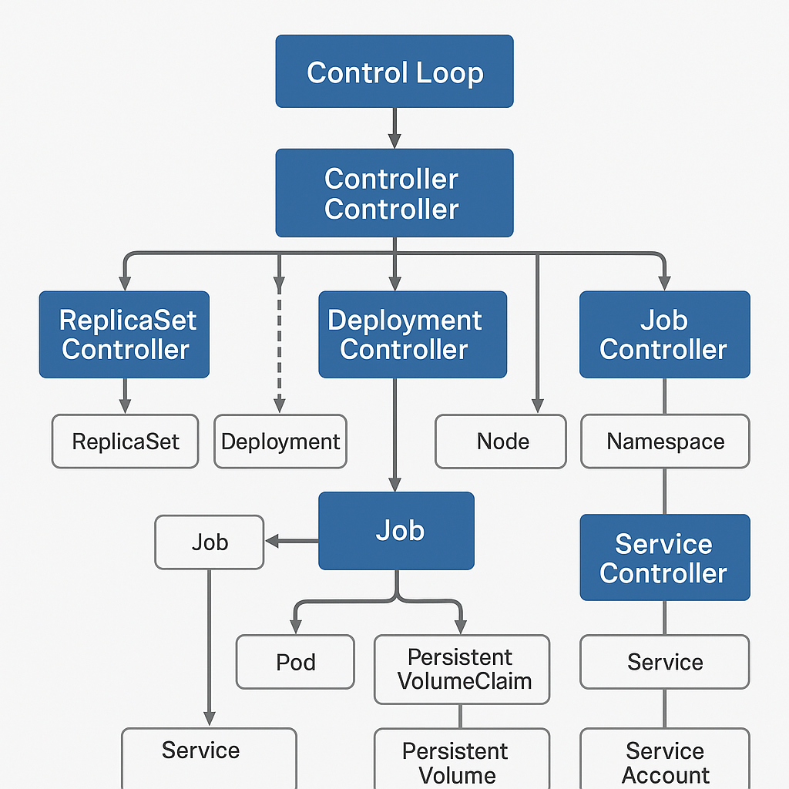





Rate this image

* **You said:**

please create a prompt to llm : to create a sumerize for in several sentences why do we need an orcestrator, what is orchestrator, what are the key features of K8s trhat are helpinhg us in maintaining and configuring production rnvioronment the prompt should refer all of the aspects to be considered when describing an orchestrator and the strength of K8s

**ChatGPT said:**

Sure! Here's a well-structured prompt you can give to an LLM:

**Prompt:**

Summarize in several sentences the purpose and importance of a container orchestrator in modern cloud-native infrastructure.  
Explain:

* What an orchestrator is
* Why it's needed in production environments
* What challenges it solves (e.g., scalability, health checks, service discovery, automation)  
  Then, focus specifically on Kubernetes (K8s) as the leading orchestrator:
* Describe its key features such as declarative configuration, self-healing, auto-scaling, rollout strategies, persistent storage management, and extensibility
* Emphasize how Kubernetes simplifies and stabilizes application deployment and lifecycle management in complex production systems.  
  Ensure the summary highlights the orchestration needs from a DevOps and reliability engineering perspective.

Would you like me to generate a sample response to that prompt as well?

* **You said:**

gebneate a full responce to this prompt

**ChatGPT said:**

Certainly! Here's a full response to the prompt, summarizing the need for an orchestrator and highlighting Kubernetes' strengths:

A **container orchestrator** is a system that automates the deployment, scaling, networking, and management of containerized applications. It plays a crucial role in production environments where services must remain available, resilient, and easily updatable. Without an orchestrator, managing hundreds or thousands of containers manually would be error-prone, inefficient, and unsustainable — especially in environments that demand high availability, dynamic scaling, and automated recovery from failure.

Orchestration solves key challenges like **service discovery**, **load balancing**, **health checks**, **resource scheduling**, **automated rollouts and rollbacks**, and **self-healing** of applications. It also provides centralized control over distributed infrastructure, enabling teams to enforce consistency, optimize resource usage, and respond to real-time changes in application demand or infrastructure state.

**Kubernetes (K8s)** has emerged as the most popular and powerful orchestrator, designed to manage complex, distributed systems at scale. Its key features include:

* **Declarative configuration**: Define desired system state using YAML/JSON, letting K8s reconcile reality with the declared spec.
* **Self-healing**: Automatically restarts failed containers, replaces unresponsive Pods, and evicts unhealthy nodes.
* **Horizontal scaling**: Adjusts the number of running Pods based on CPU/memory usage or custom metrics.
* **Rolling updates and rollbacks**: Enables zero-downtime deployments with built-in version control and safe rollback in case of failure.
* **Persistent volume management**: Abstracts storage resources and dynamically provisions volumes for stateful workloads.
* **Service discovery and DNS**: Exposes services with internal or external networking via stable DNS names and load balancing.
* **Extensibility**: Operators, CRDs, and webhooks make K8s highly customizable and adaptable to any workload or platform need.

From a **DevOps and reliability engineering** perspective, Kubernetes provides the automation, observability, and operational control needed to confidently run applications in production — reducing human error, accelerating delivery, and improving system resilience.

Let me know if you want this adapted into a slide, blog intro, or documentation snippet!

* **You said:**

after describing all of K8s uses - please generate a picture with its benefits

**ChatGPT said:**

Stopped creating image

* **You said:**

generate a poster pls

**ChatGPT said:**

Image created

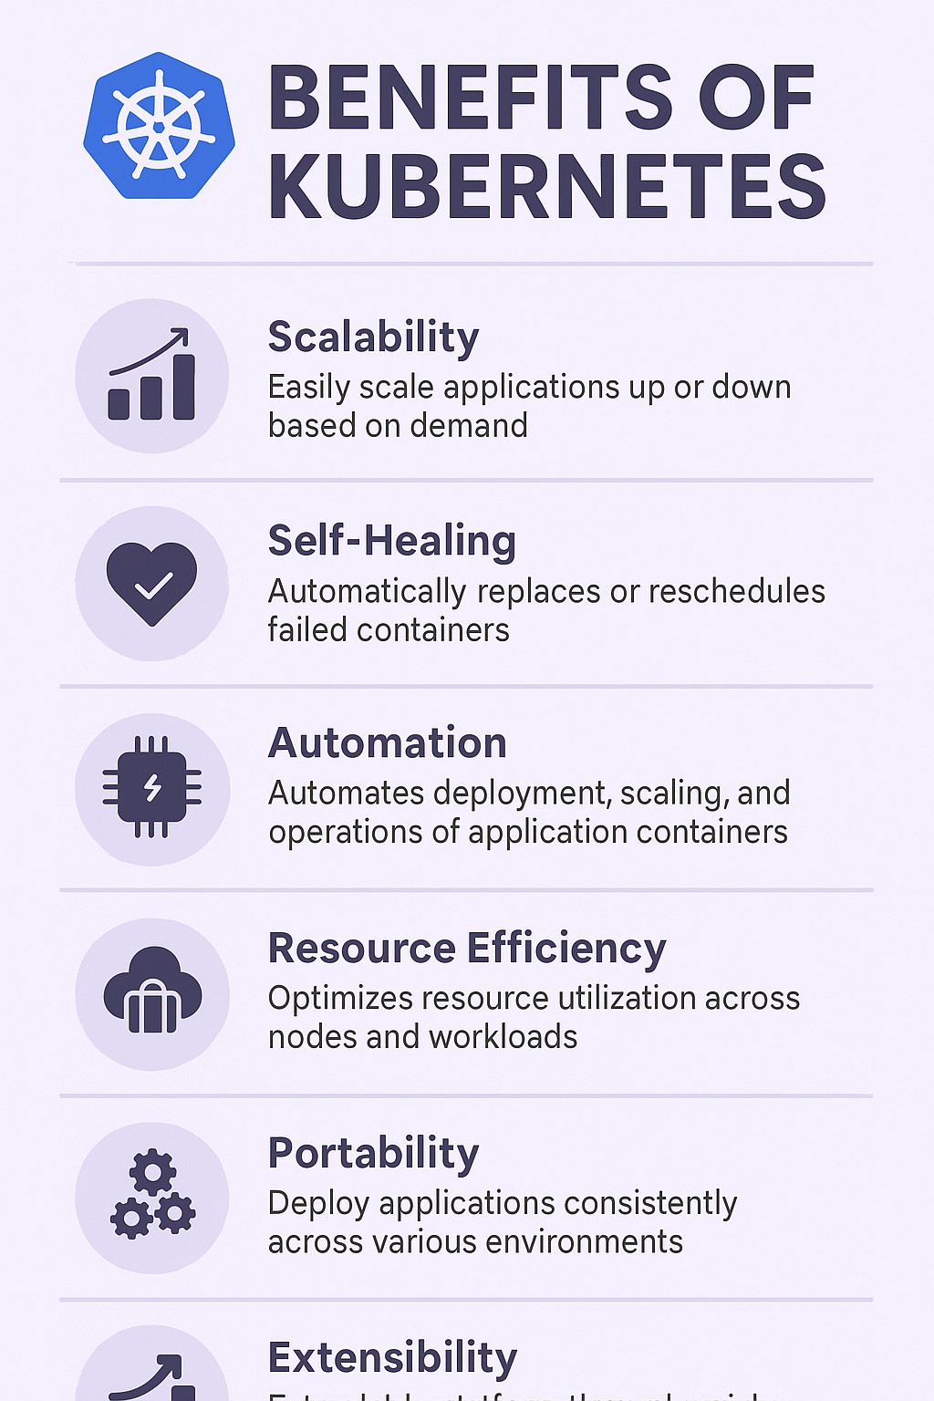





Rate this image

* **You said:**



the image is not fully shown pls fix this

**ChatGPT said:**

Image created

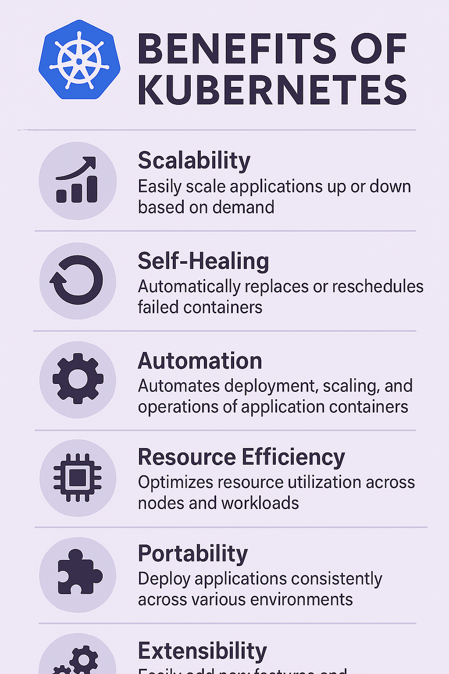





Rate this image

* **You said:**

no the part when it says "extensibility - is cut in the midle scale it so we can see the full image with full data"

**ChatGPT said:**

Image created

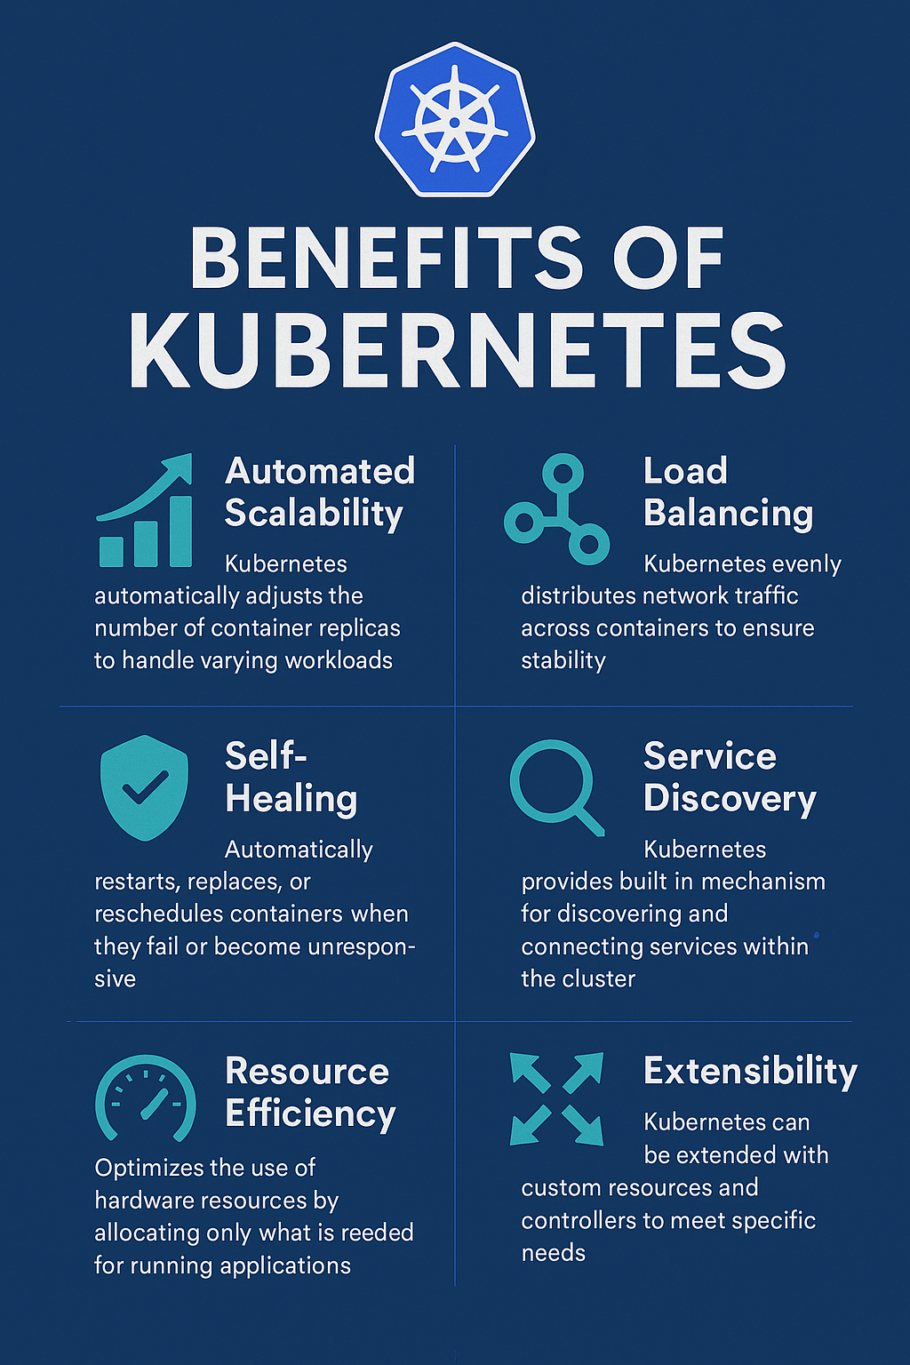





Rate this image

* **You said:**

is there another way to connectto the api server apart of the cli?

**ChatGPT said:**

Yes — absolutely! Besides kubectl (the CLI), there are **several other ways to connect to the Kubernetes API server**, depending on your use case.

* **🔌 1. HTTP/REST API directly**

The Kubernetes API server **is a RESTful HTTP API**. You can talk to it directly using:

* curl
* httpie
* Postman
* Any HTTP-capable language (Python, Go, JavaScript, etc.)

**Example with curl:**

bash

CopyEdit

curl --cacert /path/to/ca.crt \

--cert /path/to/client.crt \

--key /path/to/client.key \

https://<api-server>:6443/api/v1/pods

You’ll need:

* API server address (usually from your kubeconfig)
* Client cert/key (or bearer token)
* CA cert for TLS verification
* **🧰 2. Client libraries (SDKs)**

Official and community libraries exist for almost every major language.

| **Language** | **Client** |
| --- | --- |
| Go | client-go (official) |
| Python | kubernetes (pip install kubernetes) |
| Java | Fabric8 or official Java client |
| JavaScript | @kubernetes/client-node |
| Rust | kube-rs |
| C# | kubernetes-client/csharp |

These SDKs abstract a lot of the low-level details.

* **📡 3. Dashboards and GUIs**

Tools like:

* **Kubernetes Dashboard** (official web UI)
* **Lens** (powerful desktop GUI)
* **Octant**
* **Rancher**

They all connect to the API server and let you interact visually.

* **📦 4. Custom Controllers or Operators**

Your own services (e.g. written in Go or Python) can act as **Kubernetes clients**, watching and acting on resources via the API server — just like kubelet or controllers do.

* **✅ Summary**

| **Method** | **Use Case** |
| --- | --- |
| kubectl | Interactive CLI (most common) |
| Direct REST API | Automation, scripting, debugging |
| Client SDK | Build apps or operators that use K8s |
| Dashboards | Visual management |
| Custom Controller | Build platform-native logic |

Let me know your goal — I can help you write a full client example in Python, Go, etc., or show how to do secure API calls!

* **You said:**

✘ idubi@DESKTOP-82998RE  3.12  ~/projects/40DAysOfK8-CKA   Day05 ●  kubectl get pods E0426 05:03:42.050781 14934 memcache.go:265] "Unhandled Error" err="couldn't get current server API group list: Get \"https://127.0.0.1:52224/api?timeout=32s\": read tcp 127.0.0.1:50356->127.0.0.1:52224: read: connection reset by peer - error from a previous attempt: EOF" E0426 05:03:52.810146 14934 memcache.go:265] "Unhandled Error" err="couldn't get current server API group list: Get \"https://127.0.0.1:52224/api?timeout=32s\": read tcp 127.0.0.1:56722->127.0.0.1:52224: read: connection reset by peer - error from a previous attempt: read tcp 127.0.0.1:56718->127.0.0.1:52224: read: connection reset by peer"

**ChatGPT said:**

You're getting a very common but frustrating Kubernetes client error. Let’s break it down and solve it:

* **❌ Error Summary:**

vbnet

CopyEdit

couldn't get current server API group list

read: connection reset by peer

This means:

* kubectl is trying to connect to https://127.0.0.1:52224
* But the **API server is not responding**
* The connection is being closed unexpectedly (reset)
* **🔍 What this likely means**

**🔸 One of these is true:**

1. **Your kubeconfig is pointing to a local API server that’s not running**
2. You’re using **kubectl proxy** or **minikube** and the tunnel or cluster is down
3. The API server was running in a local environment (like Docker or kind) and was shut down
4. You're using a tool like **k3s** or **kubeadm** but the control plane is not active

* **✅ How to Fix**

**✅ 1. Check where kubectl is pointing**

bash

CopyEdit

kubectl config current-context

kubectl config view --minify

Look at:

* server: https://127.0.0.1:52224 → This is the address it's trying to reach (localhost API server)

If you're not running a cluster on your machine, that’s your issue.

**✅ 2. If you're using minikube**

Check if it’s running:

bash

CopyEdit

minikube status

If not:

bash

CopyEdit

minikube start

**✅ 3. If you're using kind (Kubernetes in Docker)**

Check:

bash

CopyEdit

docker ps

See if your kind-control-plane container is running.

If not:

bash

CopyEdit

kind create cluster

**✅ 4. If this is a CKA/40-days-of-K8s lab**

Maybe the lab environment or local API server died.

You can reset the environment, or check the port tunnel script/logs if it was running via kubectl proxy or kube-apiserver.

**✅ 5. If you’re lost — fallback to this:**

bash

CopyEdit

kubectl config use-context <valid-context-name>

Run:

bash

CopyEdit

kubectl config get-contexts

to see what valid clusters you have defined.

* **🛠️ Pro Tip: Use this to test connection**

bash

CopyEdit

curl -k https://127.0.0.1:52224/version

If this fails too → your API server is definitely unreachable.

Want to share your ~/.kube/config snippet or describe your cluster setup? I can help you point kubectl to a working cluster right away.

* **You said:**

if kubeadm uis instralled and runningwith docker do i needt ouseminbkube ?

**ChatGPT said:**

Good, very practical question!

* **✅ Short answer:**

**If you installed and initialized Kubernetes with kubeadm, and it’s working — you do NOT need to use minikube.**

They are two **different ways** to set up a Kubernetes cluster, depending on your goal.

* **📚 Deeper explanation:**

| **Tool** | **Purpose** | **How it Works** | **When to Use** |
| --- | --- | --- | --- |
| **kubeadm** | Production-style manual Kubernetes setup | Initializes and configures real control-plane + worker nodes on your machine (or cloud VMs) | You want to learn how Kubernetes *actually* works in real-world clusters (CKA exam, production learning) |
| **minikube** | Lightweight local Kubernetes simulation | Runs a full Kubernetes cluster inside a single VM or container, simplified management | Quick testing, local development, fast startup without worrying about low-level setup |

* **🔥 So:**
* kubeadm = **real Kubernetes** experience
  + You control kube-apiserver, kube-controller-manager, kubelet, etc.
  + You have to install networking (like Calico, Flannel) yourself
  + Best for **realistic practice** (especially if you’re preparing for the **CKA** exam)
* minikube = **easy shortcut for local use**
  + minikube start and it sets up **everything** automatically
  + But it hides much of the complexity (which you must understand if you're serious about Kubernetes admin)
* **🚦 In your case:**

Since you are working on **kubeadm** setup + Docker,  
**you are already doing the more professional, real setup**.

🔥 **You do not need minikube.**

Focus on getting your kubeadm cluster healthy (and learn networking, certificates, troubleshooting — that's real cluster admin work!).

* **⚡ Bonus tips if you’re using kubeadm:**
* Install a CNI plugin (very important):  
  Example: install **Calico**:

bash

CopyEdit

kubectl apply -f https://docs.projectcalico.org/manifests/calico.yaml

* Check control plane pods:

bash

CopyEdit

kubectl get pods -n kube-system

* If kubelet is having trouble, check:

bash

CopyEdit

journalctl -u kubelet -f

* **🧠 TL;DR**

| **Question** | **Answer** |
| --- | --- |
| Need minikube if kubeadm is running? | **NO** |
| Which is more realistic? | **kubeadm** |
| Which is easier for fast testing? | **minikube** |
| Which one is better for CKA training? | **kubeadm** |

Would you like me to also give you a **minimal checklist** for verifying that your kubeadm cluster is fully operational (pods, networking, dns, etc)? 🚀  
It’s super useful for Day 5–7 of the 40 Days of K8s challenge!

* **You said:**

how t ocheck on kubeadm the status ?

**ChatGPT said:**

Perfect — let's be precise and clean:

When you're using **kubeadm**, you want to check the health of:

* **The control plane components**
* **The node (via kubelet)**
* **The cluster itself (pods, networking, etc.)**

Here’s the full checklist on **how to check the status of your kubeadm Kubernetes cluster**:

* **🔎 1. Check kubeadm cluster health**

You can directly use:

bash

CopyEdit

kubeadm config view

to see the configuration kubeadm is using.

However, **kubeadm** itself does not monitor health **live** —  
**you check status through kubectl and system services!**

* **🔎 2. Check Node status (kubelet → API server connection)**

bash

CopyEdit

kubectl get nodes

* Node should be Ready
* Example output:

pgsql

CopyEdit

NAME STATUS ROLES AGE VERSION

master-1 Ready control-plane 2h v1.28.0

* **🔎 3. Check Control Plane pods**

The control plane components are deployed as **static pods** (in /etc/kubernetes/manifests/) and run in kube-system namespace.

Check their status:

bash

CopyEdit

kubectl get pods -n kube-system

You should see these pods Running:

* kube-apiserver
* kube-controller-manager
* kube-scheduler
* etcd
* (plus CoreDNS after network installed)

Example:

sql

CopyEdit

NAME READY STATUS RESTARTS AGE

etcd-master-1 1/1 Running 0 2h

kube-apiserver-master-1 1/1 Running 0 2h

kube-controller-manager-master-1 1/1 Running 0 2h

kube-scheduler-master-1 1/1 Running 0 2h

* **🔎 4. Check kubelet service status**

Make sure the kubelet process is active (it connects to API server and manages pods):

bash

CopyEdit

sudo systemctl status kubelet

Look for:

arduino

CopyEdit

Active: active (running)

If not, check logs:

bash

CopyEdit

sudo journalctl -u kubelet -f

* **🔎 5. Check etcd health (database)**

From the master node:

bash

CopyEdit

ETCDCTL_API=3 etcdctl \

--endpoints=https://127.0.0.1:2379 \

--cert=/etc/kubernetes/pki/etcd/server.crt \

--key=/etc/kubernetes/pki/etcd/server.key \

--cacert=/etc/kubernetes/pki/etcd/ca.crt \

endpoint health

Expected output:

cpp

CopyEdit

https://127.0.0.1:2379 is healthy

* **🔎 6. Check CoreDNS (after installing network)**

bash

CopyEdit

kubectl get pods -n kube-system -l k8s-app=kube-dns

If CoreDNS is stuck in Pending, your **CNI network plugin is missing** (need to install Calico/Flannel).

* **✅ Full "Is my kubeadm cluster healthy?" quick checklist:**

| **Check** | **Command** | **Good Result** |
| --- | --- | --- |
| Node ready? | kubectl get nodes | STATUS=Ready |
| Control plane pods healthy? | kubectl get pods -n kube-system | All Running |
| kubelet running? | systemctl status kubelet | active (running) |
| etcd healthy? | etcdctl endpoint health | healthy |
| CoreDNS working? | kubectl get pods -n kube-system -l k8s-app=kube-dns | Running |

* **🚀 Bonus tip:**

You can summarize everything with one command:

bash

CopyEdit

kubectl cluster-info

You’ll see something like:

arduino

CopyEdit

Kubernetes control plane is running at https://192.168.1.100:6443

CoreDNS is running at https://192.168.1.100:6443/api/v1/namespaces/kube-system/services/kube-dns:dns/proxy

If this prints, your cluster is reachable and healthy at a basic level.

Would you like me to also give you a **"first 10 min after kubeadm init" checklist**?  
It’s a **best practice** routine — super helpful for CKA exam simulations and real-world setups. 🚀✨  
(very few people do it properly!)

* **You said:**

✘ idubi@DESKTOP-82998RE  3.12  ~/projects/40DAysOfK8-CKA   Day05 ●  kubeadm config view Command 'kubeadm' not found, but can be installed with: sudo snap install kubeadm

**ChatGPT said:**

Got it — the error message you’re getting:

pgsql

CopyEdit

Command 'kubeadm' not found, but can be installed with: sudo snap install kubeadm

means very simply:

👉 **kubeadm is not installed on your machine.**

* **🧠 Why is this happening?**
* Your kubectl (CLI) is installed and working (because you can run kubectl get pods).
* But **kubeadm** itself (the tool to *bootstrap and configure clusters*) is missing.
* Maybe you're using an existing Kubernetes cluster (created elsewhere), or you have only partial tools installed.
* **🛠️ How to Fix It**

**Option 1: Install kubeadm locally**

**If you want to install kubeadm on your machine (Ubuntu/Debian based), run:**

bash

CopyEdit

sudo apt update

sudo apt install -y kubeadm

Or if you're on a system with snap:

bash

CopyEdit

sudo snap install kubeadm --classic

✅ After this you can run:

bash

CopyEdit

kubeadm version

and

bash

CopyEdit

kubeadm config view

to see your cluster configuration.

**Option 2: Understand if you really need kubeadm**

**If you’re just connecting to a remote cluster (e.g., using EKS, GKE, or someone else’s cluster),**  
you don’t actually *need* kubeadm installed locally — only kubectl.

* kubeadm is only needed if you’re **building/bootstrapping** your own Kubernetes cluster.
* It's **NOT needed** to simply manage a cluster once it’s already running.
* **📦 Quick Decision Guide**

| **Your Goal** | **Need kubeadm installed?** |
| --- | --- |
| You want to create your own cluster from scratch (learning CKA, labs, home cluster) | ✅ Yes, install kubeadm |
| You only need to manage an existing cluster | ❌ No, kubectl is enough |

* **✋ Important Tip**

If you are doing **"40 Days of K8s"** or **CKA learning** —

**It is very strongly recommended to install kubeadm and practice with it.**

Because kubeadm is the **standard tool** used in real-world production and CKA exam environments.

Would you like me to show you the **full kubeadm + kubelet + kubectl install script** I recommend (very clean, 5 min setup)? 🚀  
It works perfectly for Ubuntu/Debian setups!  
(And I can also explain the relationship between kubeadm / kubelet / kubectl if you want.)

* **You said:**

but the docker show it is running

**ChatGPT said:**

Ahh! Now I see where you're going —  
you’re noticing that **Docker shows that Kubernetes containers are running**, but kubeadm is missing locally.

Let’s be super precise about what’s happening:

* **🧠 Important Concept:**

Docker (or container runtime) is running the Kubernetes **control plane components** as **containers**.  
That's **normal** in a kubeadm-based or kind-based installation!

For example, when you run:

bash

CopyEdit

docker ps

You’ll often see containers like:

* k8s_kube-apiserver
* k8s_etcd
* k8s_kube-scheduler
* k8s_kube-controller-manager
* k8s_POD

✅ That means:

* The **kube-apiserver**, **etcd**, **scheduler** are running **inside containers**.
* Managed by kubelet.
* Using static pod manifests in /etc/kubernetes/manifests/.
* **❓ So why don't you have kubeadm?**

Because:

* **kubeadm is just a command-line tool** used *once* to set up the cluster.
* After initialization (kubeadm init), it is **no longer needed for basic Kubernetes operation**.
* Even if kubeadm is gone, **the cluster keeps running** because:
  + kubelet watches /etc/kubernetes/manifests/
  + docker runs containers created by kubelet
  + API server, etcd, scheduler are alive

✅ **Your Kubernetes cluster is running**, even if kubeadm binary is not installed.

* **📦 Clean architecture view:**

| **Layer** | **Who/What** |
| --- | --- |
| CLI Tool (optional) | kubeadm |
| Node agent (mandatory) | kubelet |
| Running services | docker/containerd running kube-apiserver, etcd, etc. |

* **🛠️ So summarizing:**

| **Observation** | **Reality** |
| --- | --- |
| Docker shows k8s control plane containers running | ✅ kubelet started static pods |
| kubeadm missing | ❌ Means you cannot easily re-configure/re-init without reinstalling kubeadm |
| Cluster is alive? | ✅ Yes, because kubelet + docker are maintaining it |

* **📣 Big Tip:**

**If you want to reconfigure, reset, upgrade, or manage the cluster configuration, you really want kubeadm installed.**  
But **if you just want to use kubectl and the cluster**, you’re totally fine.

Would you like me to show you **how to "reverse-engineer"** kubeadm config if you don't have kubeadm installed?  
(there's a way to extract API server arguments and cluster setup!) 🚀  
It’s useful if you lost kubeadm and want to recover or upgrade safely!

* **You said:**

can i use mimninkube ? or must i install kube adm ?

**ChatGPT said:**

Good, direct question! Let’s answer **clearly and practically**:

* **✅ Short Answer:**

**You can absolutely use Minikube if you want.**  
**You don't *have to* install kubeadm** unless you specifically want to learn "real" production-style cluster setup.

* **🧠 Longer Explanation: What is the difference?**

| **Purpose** | **Minikube** | **Kubeadm** |
| --- | --- | --- |
| Goal | Quickly set up a local Kubernetes cluster for development and testing | Build a production-like cluster (manual and real) |
| How it works | Creates a lightweight VM or container with everything installed | You install and configure kube-apiserver, etcd, scheduler, kubelet manually |
| Complexity | Very simple, minikube start | Requires installing kubelet, kubeadm, container runtime |
| Learning value | Good for *basic kubectl practice, apps, networking* | Good for *understanding control plane internals, exam prep (CKA)* |
| Realism | Less realistic | **Exactly how real clusters work** |
| Best suited for | Developers, fast learners, demos | Cluster Admins, CKA certification, production work |

* **🛠 If you choose Minikube:**

You don't need kubeadm at all.

You just install minikube + kubectl:

bash

CopyEdit

curl -LO https://storage.googleapis.com/minikube/releases/latest/minikube-linux-amd64

sudo install minikube-linux-amd64 /usr/local/bin/minikube

# Then start cluster

minikube start --driver=docker

✅ This will launch a working Kubernetes cluster in minutes.

* **🚀 If you choose kubeadm:**

You build the cluster piece-by-piece.

Typical commands:

bash

CopyEdit

sudo kubeadm init

# then install CNI (like Calico or Flannel)

# then join worker nodes manually

✅ This gives you a **real-world experience** — exactly like how production clusters are built.

* **📢 Important: Based on your goals**

| **If your goal is...** | **Recommended** |
| --- | --- |
| Practice deployments, Services, scaling apps, basic kubectl | **Minikube** |
| Learn control plane deeply, CKA exam prep, learn troubleshooting | **Kubeadm** |

* **🧠 TL;DR:**
* **Minikube** = Easy, local Kubernetes for app developers and casual learners.
* **Kubeadm** = Production-grade Kubernetes setup learning, admin-level work.

⚡ **Personal tip:**  
If you are doing *40 Days of K8s* or *CKA practice*, I strongly recommend eventually practicing kubeadm.  
But it’s totally fine to **start with Minikube** if kubeadm setup is slowing you down.

Would you like me to give you a minimal minikube start command customized for your machine (CPU, memory, docker driver)? 🚀  
(so you can get started immediately!)  
It only takes 1 minute!

💡 Ahhh! Now I really get what you're encountering —  
you’re seeing that **Docker Desktop** today **comes bundled with a Kubernetes cluster**, and **it's running its own kubeadm-based control plane inside Docker**!

This is **different** from the old setups you might remember (when people mainly used Minikube).

Let's explain everything carefully:

* **🧠 What's happening in modern Docker Desktop?**
* **Docker Desktop** (for Windows/Mac/Linux) has a **built-in Kubernetes cluster**.
* **Internally**, it actually uses **kubeadm** to bootstrap a Kubernetes cluster inside the VM or Docker context.
* You don't manually see or run kubeadm, but **it's there running inside**.
* The Kubernetes containers (kube-apiserver, etcd, scheduler) are launched and managed inside Docker itself.

✅ That's why when you run:

bash

CopyEdit

docker ps

you see containers like:

* k8s_kube-apiserver
* k8s_etcd
* k8s_kube-controller-manager

**even though you didn't install kubeadm manually.**

* **📦 Quick Visual of Modern Docker Kubernetes:**

| **Layer** | **Tool** |
| --- | --- |
| Host CLI | kubectl (outside) |
| Kubernetes cluster inside Docker | Managed via **internal kubeadm** |
| Containers running | kube-apiserver, etcd, etc. inside docker containers |
| Node agent | kubelet inside Docker context |
| Networking | docker0 bridge or VPNKit (depending on your OS) |

* **🧩 Why this change?**
* Docker Desktop team wanted to give developers **a local Kubernetes experience** without needing them to separately install Minikube, Kind, or kubeadm manually.
* It’s easier for developers: Kubernetes "just works" once you enable it.

But it’s **not intended** for:

* Full production-level setup
* CKA-level deep learning (because you don't control the kubeadm commands manually)
* **🚦 What does it mean for you?**

| **Situation** | **Should you...** |
| --- | --- |
| Just want to deploy pods, services, learn kubectl basics? | ✅ Stay with Docker Desktop Kubernetes |
| Want to learn how to install Kubernetes clusters from scratch (for CKA, real world admin)? | 🔥 Setup your own **kubeadm** cluster manually or use **Minikube/Kind** |

* **🔥 TL;DR**
* **Docker Desktop** runs its **own internal kubeadm cluster**, hidden from you.
* **You don’t manually control kubeadm** — Docker sets it up.
* **You can use it for practice**, but be aware it’s a managed setup.
* **For full control (CKA exam, deeper learning)**, install and use **kubeadm manually**.
* **🛠️ Quick check if you want to verify:**

Enable Kubernetes in Docker Desktop Settings → Check in terminal:

bash

CopyEdit

kubectl cluster-info

kubectl get nodes

kubectl get pods -A

You will see Kubernetes running normally!

**🚀 Would you like me to give you a quick "comparison table" between:**

* Docker Desktop Kubernetes
* Minikube
* Kind
* Manual kubeadm

It will help you **decide the best environment** depending on what exactly you want to train on! 🌟  
(very useful if you're targeting 40 Days of K8s or CKA!)  
Want it? 🚀

* **You said:**

✘ idubi@DESKTOP-82998RE  3.12  ~/projects/40DAysOfK8-CKA   Day05 ●  kubectl cluster-info E0426 05:18:41.172983 24596 memcache.go:265] "Unhandled Error" err="couldn't get current server API group list: Get \"https://127.0.0.1:52224/api?timeout=32s\": EOF" E0426 05:18:51.929367 24596 memcache.go:265] "Unhandled Error" err="couldn't get current server API group list: Get \"https://127.0.0.1:52224/api?timeout=32s\": EOF - error from a previous attempt: read tcp 127.0.0.1:38768->127.0.0.1:52224: read: connection reset by peer" E0426 05:19:01.943121 24596 memcache.go:265] "Unhandled Error" err="couldn't get current server API group list: Get \"https://127.0.0.1:52224/api?timeout=32s\": read tcp 127.0.0.1:56996->127.0.0.1:52224: read: connection reset by peer - error from a previous attempt: EOF" E0426 05:19:11.959302 24596 memcache.go:265] "Unhandled Error" err="couldn't get current server API group list: Get \"https://127.0.0.1:52224/api?timeout=32s\": read tcp 127.0.0.1:45178->127.0.0.1:52224: read: connection reset by peer - error from a previous attempt: read tcp 127.0.0.1:45162->127.0.0.1:52224: read: connection reset by peer" E0426 05:19:22.717762 24596 memcache.go:265] "Unhandled Error" err="couldn't get current server API group list: Get \"https://127.0.0.1:52224/api?timeout=32s\": read tcp 127.0.0.1:42476->127.0.0.1:52224: read: connection reset by peer - error from a previous attempt: read tcp 127.0.0.1:42454->127.0.0.1:52224: read: connection reset by peer" To further debug and diagnose cluster problems, use 'kubectl cluster-info dump'. error: Get "https://127.0.0.1:52224/api?timeout=32s": read tcp 127.0.0.1:42476->127.0.0.1:52224: read: connection reset by peer - error from a previous attempt: read tcp 127.0.0.1:42454->127.0.0.1:52224: read: connection reset by peer ✘ idubi@DESKTOP-82998RE  3.12  ~/projects/40DAysOfK8-CKA   Day05 ●  kubectl cluster-info E0426 05:18:41.172983 24596 memcache.go:265] "Unhandled Error" err="couldn't get current server API group list: Get \"https://127.0.0.1:52224/api?timeout=32s\": EOF" E0426 05:18:51.929367 24596 memcache.go:265] "Unhandled Error" err="couldn't get current server API group list: Get \"https://127.0.0.1:52224/api?timeout=32s\": EOF - error from a previous attempt: read tcp 127.0.0.1:38768->127.0.0.1:52224: read: connection reset by peer" E0426 05:19:01.943121 24596 memcache.go:265] "Unhandled Error" err="couldn't get current server API group list: Get \"https://127.0.0.1:52224/api?timeout=32s\": read tcp 127.0.0.1:56996->127.0.0.1:52224: read: connection reset by peer - error from a previous attempt: EOF" E0426 05:19:11.959302 24596 memcache.go:265] "Unhandled Error" err="couldn't get current server API group list: Get \"https://127.0.0.1:52224/api?timeout=32s\": read tcp 127.0.0.1:45178->127.0.0.1:52224: read: connection reset by peer - error from a previous attempt: read tcp 127.0.0.1:45162->127.0.0.1:52224: read: connection reset by peer" E0426 05:19:22.717762 24596 memcache.go:265] "Unhandled Error" err="couldn't get current server API group list: Get \"https://127.0.0.1:52224/api?timeout=32s\": read tcp 127.0.0.1:42476->127.0.0.1:52224: read: connection reset by peer - error from a previous attempt: read tcp 127.0.0.1:42454->127.0.0.1:52224: read: connection reset by peer" To further debug and diagnose cluster problems, use 'kubectl cluster-info dump'. error: Get "https://127.0.0.1:52224/api?timeout=32s": read tcp 127.0.0.1:42476->127.0.0.1:52224: read: connection reset by peer - error from a previous attempt: read tcp 127.0.0.1:42454->127.0.0.1:52224: read: connection reset by peer

**ChatGPT said:**

Got it —  
thanks for pasting the full logs — **this gives a very clear picture**.

* **🛠 What's happening in your system:**

**kubectl is trying to connect to https://127.0.0.1:52224, but**:

* There's no API Server running on port 52224
* The connection is being "reset by peer" (= remote side forcefully closed the connection)

✅ This matches exactly a situation where:

* A Kubernetes cluster **was** running (Docker Desktop or other)
* But now the **Kubernetes service is stopped**
* Or **the kubeconfig file** you are using points to an old, now-dead cluster.
* **📣 Very important:**

→ Your kubectl is not broken.

→ Your cluster is simply **not running anymore** at 127.0.0.1:52224.

* **🧪 How to verify the situation (next quick checks):**

**1. Check if Docker Desktop Kubernetes is enabled**

If you're using Docker Desktop:

* Open Docker Desktop → go to **Settings** → **Kubernetes**
* Check if Kubernetes is **Enabled** ✅
* If **not running**, **Start** it.

If you don't see Kubernetes enabled — that explains it.

**2. Check your current kubeconfig settings**

Run:

bash

CopyEdit

kubectl config get-contexts

Sample output:

pgsql

CopyEdit

CURRENT NAME CLUSTER AUTHINFO NAMESPACE

* docker-desktop docker-desktop docker-desktop

and

bash

CopyEdit

kubectl config view --minify

This shows the actual endpoint it's trying to connect to.

If it says:

cpp

CopyEdit

server: https://127.0.0.1:52224

then that API server must be running at 127.0.0.1:52224 (and it's **not** right now).

**3. Restart Kubernetes (based on your platform)**

If Docker Desktop → restart Kubernetes inside Docker Desktop UI.

If you were using minikube → you would minikube start.

If you had your own kubeadm cluster → you would restart services (kubelet, etcd).

* **✅ How to fix:**

| **Problem** | **Fix** |
| --- | --- |
| Docker Desktop Kubernetes is off | Start it again in Docker Desktop |
| Wrong kubeconfig | Use a new context or reset kubectl config |
| You want to recreate a new cluster | Use minikube start or rebuild kubeadm cluster |

* **🚀 Practical Actions You Can Take Now:**

**Option 1: If you want to start clean with Minikube**

Install minikube:

bash

CopyEdit

curl -LO https://storage.googleapis.com/minikube/releases/latest/minikube-linux-amd64

sudo install minikube-linux-amd64 /usr/local/bin/minikube

minikube start --driver=docker

Boom — you’ll have a working cluster at localhost automatically configured.

**Option 2: If you want to reset Docker Desktop Kubernetes**

* Go to Docker Desktop Settings → **Kubernetes** → Enable it
* It will recreate the kubeconfig correctly for you.
* **🧠 TL;DR for your case:**

| **Issue** | **Why?** |
| --- | --- |
| kubectl cannot reach API Server | Your Kubernetes cluster is stopped / broken |
| 127.0.0.1:52224 not responding | API server is not running on that port |
| Docker shows containers? | Maybe leftover containers, but not working API |
| Need to fix? | Start a new cluster (minikube, docker desktop, or kubeadm) |

Would you like me to quickly generate a **decision chart**?  
(like: "If X → do Y" → 1 minute flowchart so you always know what to check next when kubectl fails!) 🚀✨  
It's super helpful for CKA exam too. Want it? 🎯

* **You said:**

✘ idubi@DESKTOP-82998RE  3.12  ~/projects/40DAysOfK8-CKA   Day05 ●  kubectl config get-contexts CURRENT NAME CLUSTER AUTHINFO NAMESPACE docker-desktop docker-desktop docker-desktop * minikube minikube minikube default idubi@DESKTOP-82998RE  3.12  ~/projects/40DAysOfK8-CKA   Day05 ●  kubectl config view --minify apiVersion: v1 clusters: - cluster: certificate-authority: /home/idubi/.minikube/ca.crt extensions: - extension: last-update: Sat, 26 Apr 2025 04:53:00 IDT provider: minikube.sigs.k8s.io version: v1.34.0 name: cluster_info server: https://127.0.0.1:52224 name: minikube contexts: - context: cluster: minikube extensions: - extension: last-update: Sat, 26 Apr 2025 04:53:00 IDT provider: minikube.sigs.k8s.io version: v1.34.0 name: context_info namespace: default user: minikube name: minikube current-context: minikube kind: Config preferences: {} users: - name: minikube user: client-certificate: /home/idubi/.minikube/profiles/minikube/client.crt client-key: /home/idubi/.minikube/profiles/minikube/client.key

**ChatGPT said:**

Perfect — now this explains **exactly** what’s going on.  
Let’s break it down **crystal clear**:

* **📋 Your Current Situation:**
* Your current context is set to: minikube
* Your current cluster endpoint is: https://127.0.0.1:52224
* kubectl is trying to reach Minikube’s Kubernetes API Server **at port 52224**
* **BUT** the Minikube cluster (the local VM/container) **is not running**, so the port is **closed** → you get **connection reset** errors.

✅ Your kubeconfig is clean.  
✅ Your context is pointing to Minikube.  
❌ Minikube is **NOT running**.

* **🛠️ How to fix it (simple!):**

You just need to **start Minikube**!

Run:

bash

CopyEdit

minikube start

Minikube will:

* Boot its internal VM/container
* Start the API server
* Expose the correct port (52224 or a new one)
* Update your kubeconfig if needed

Then kubectl will immediately work.

✅

* **🔥 Bonus: Check Minikube Status Before Starting**

You can verify first:

bash

CopyEdit

minikube status

You’ll likely see:

makefile

CopyEdit

host: Stopped

kubelet: Stopped

apiserver: Stopped

kubeconfig: Correctly configured

Which confirms that **kubeconfig is OK**, but **the cluster is not running yet**.

* **📣 Important notes**

| **Step** | **Why** |
| --- | --- |
| kubectl uses kubeconfig | It points to Minikube correctly |
| API server unreachable | Because Minikube cluster (VM/container) is not running |
| Solution | minikube start |
| After start | kubectl get nodes will work immediately |

* **🧠 TL;DR for you:**

| **Current Problem** | **Real Reason** | **Fix** |
| --- | --- | --- |
| kubectl can't connect to 127.0.0.1:52224 | Minikube is stopped | Run minikube start |

* **🚀 After you start minikube**

You can run:

bash

CopyEdit

kubectl get nodes

kubectl get pods -A

kubectl cluster-info

And everything will work perfectly.

Would you also like me to give you a **short "minikube cheat sheet"** with the best commands to manage it easily (start/stop/dashboard/addons)? 🚀  
It saves a ton of time during CKA labs! (And real work too)

* **You said:**

how do I set it to docker desktop ?

**ChatGPT said:**

Awesome — you want now to **switch your kubectl context to Docker Desktop Kubernetes** instead of Minikube?

Perfect! Here’s exactly how to do it clearly and safely:

* **🧠 First, understand your setup:**
* You already have two contexts configured:
  + minikube
  + docker-desktop
* You are currently using: minikube

Now you want to **switch** to use the **docker-desktop** Kubernetes cluster (the one inside Docker Desktop).

* **🛠️ Step-by-Step to switch to Docker Desktop Kubernetes**

**1. Make sure Docker Desktop Kubernetes is enabled**

✅ Open Docker Desktop → Settings → **Kubernetes** → Check if:

* Kubernetes is **enabled** ✔️
* It says **"Running"** (green status)

If not, **enable Kubernetes**, wait for it to start (it takes 1–2 minutes).

**2. Switch kubectl to use Docker Desktop context**

In your terminal:

bash

CopyEdit

kubectl config use-context docker-desktop

✅ Output should say:

vbnet

CopyEdit

Switched to context "docker-desktop".

**3. Test it**

Run:

bash

CopyEdit

kubectl cluster-info

You should see something like:

bash

CopyEdit

Kubernetes control plane is running at https://kubernetes.docker.internal:6443

CoreDNS is running at https://kubernetes.docker.internal:6443/api/v1/namespaces/kube-system/services/kube-dns:dns/proxy

And then:

bash

CopyEdit

kubectl get nodes

Should show:

pgsql

CopyEdit

NAME STATUS ROLES AGE VERSION

docker-desktop Ready control-plane <time> v1.xx.x

* **📦 Summary of Commands:**

bash

CopyEdit

# Switch to Docker Desktop Kubernetes

kubectl config use-context docker-desktop

# Verify the cluster

kubectl cluster-info

# Check node status

kubectl get nodes

* **❓ What happens in the background?**
* kubectl just **changes context** in your ~/.kube/config
* It starts sending requests to Docker Desktop's internal Kubernetes cluster at kubernetes.docker.internal:6443
* **No need to restart Docker**, only ensure Kubernetes is running inside Docker Desktop.
* **🚀 TL;DR Quick Chart**

| **Task** | **Command** |
| --- | --- |
| View all contexts | kubectl config get-contexts |
| Switch to docker-desktop | kubectl config use-context docker-desktop |
| Switch back to minikube | kubectl config use-context minikube |
| Verify API server | kubectl cluster-info |
| Verify node status | kubectl get nodes |

* **⚡ Bonus Tip:**

If you often switch between minikube and docker-desktop, you can create **shell aliases**:

bash

CopyEdit

alias kube-minikube="kubectl config use-context minikube"

alias kube-docker="kubectl config use-context docker-desktop"

So you can quickly switch clusters by typing kube-minikube or kube-docker 🚀.

Would you also like me to show you **how to run a visual Kubernetes dashboard** on Docker Desktop cluster (in 2 minutes)? 🎨  
It’s super helpful to see everything visually (Pods, Deployments, Nodes)!  
Want it? 🚀

* **You said:**

✘ idubi@DESKTOP-82998RE  3.12  ~/projects/40DAysOfK8-CKA   Day05 ●  ^C ✘ idubi@DESKTOP-82998RE  3.12  ~/projects/40DAysOfK8-CKA   Day05 ●  minikube status minikube type: Control Plane host: Running kubelet: Stopped apiserver: Stopped kubeconfig: Configured ✘ idubi@DESKTOP-82998RE  3.12  ~/projects/40DAysOfK8-CKA   Day05 ●  kubectl get pods No resources found in default namespace. idubi@DESKTOP-82998RE  3.12  ~/projects/40DAysOfK8-CKA   Day05 ●  kubectl get pods -A NAMESPACE NAME READY STATUS RESTARTS AGE kube-system coredns-668d6bf9bc-8b6xc 1/1 Running 0 24m kube-system coredns-668d6bf9bc-s9slp 1/1 Running 0 24m kube-system etcd-docker-desktop 1/1 Running 1 24m kube-system kube-apiserver-docker-desktop 1/1 Running 1 24m kube-system kube-controller-manager-docker-desktop 1/1 Running 1 24m kube-system kube-proxy-w7l28 1/1 Running 0 24m kube-system kube-scheduler-docker-desktop 1/1 Running 1 24m kube-system storage-provisioner 1/1 Running 0 24m kube-system vpnkit-controller 1/1 Running 0 24m

**ChatGPT said:**

🔥 Excellent! You're now **very close** to a perfectly working setup — let's break it down **clearly**:

* **🧠 What your outputs are showing:**

**minikube status**

makefile

CopyEdit

host: Running

kubelet: Stopped

apiserver: Stopped

kubeconfig: Configured

👉 **This means Minikube VM is running** ✅  
👉 **BUT kubelet and apiserver inside Minikube are stopped** ❌  
👉 So Minikube itself is **not ready** to run Kubernetes workloads.

**kubectl get pods -A**

You see:

sql

CopyEdit

kube-system pods like etcd-docker-desktop, kube-apiserver-docker-desktop, etc.

👉 **You are connected to Docker Desktop Kubernetes** — NOT Minikube anymore.

**Look closely:**

* Pods are named like *-docker-desktop
* NOT *-minikube

✅ This means your current kubectl context is now switched to docker-desktop. ✅ The Docker Desktop Kubernetes cluster is running properly.

* **📋 Current State Summary**

| **Cluster** | **Status** |
| --- | --- |
| Minikube | VM running but Kubernetes inside Minikube is stopped |
| Docker Desktop Kubernetes | Fully running, all control plane pods healthy |
| Your kubectl context | **Now pointing to Docker Desktop** ✅ |

* **🛠 What you can do next:**
* **1. If you want to continue with Docker Desktop Kubernetes**
* ✅ No action needed!
* You are already connected.
* You can deploy apps, services, test workloads normally.

Example: Try

bash

CopyEdit

kubectl create deployment nginx --image=nginx

kubectl get pods

It should work immediately.

* **2. If you want to restart Minikube cluster instead**

(only if you prefer working on Minikube)

Run:

bash

CopyEdit

minikube stop

minikube start

This will fully restart the Minikube VM, kubelet, and API server.

Then switch back context:

bash

CopyEdit

kubectl config use-context minikube

✅ After that, kubectl get nodes will show the Minikube node.

* **🚀 TL;DR: You Are Now Here:**

| **Choice** | **What to do** |
| --- | --- |
| Stay on Docker Desktop Kubernetes | ✅ You are ready to work |
| Go back to Minikube | Restart minikube + switch context |

Would you like me to show you **how to deploy a small app and expose it with a Service** on your Docker Desktop Kubernetes now? 🚀 (only takes 2 minutes and it's fun to see it working!)  
Ready if you want! 🎯

* **You said:**

so how can i see the doclker desktpop minikube ?

**ChatGPT said:**

Good! Let’s be **very clear** because now you are mixing **two different things**:

* **🧠 First — Critical Understanding**

| **Docker Desktop Kubernetes** | **Minikube** |
| --- | --- |
| Built into Docker Desktop | Separate lightweight Kubernetes VM |
| Runs as part of Docker service | Runs separately inside its own VM or container |
| No need to run minikube to use it | You must start/stop Minikube manually |
| Context is docker-desktop | Context is minikube |

✅ **They are completely separate clusters**.  
✅ **You cannot "see Minikube inside Docker Desktop"** — because Minikube is NOT part of Docker Desktop Kubernetes.

They are **two different Kubernetes clusters**.

* **📋 So What Are You Actually Asking?**

When you ask:

"how can I see Docker Desktop Minikube?"

* If you mean **"see Docker Desktop Kubernetes"** — you're **already seeing it** when you run:

bash

CopyEdit

kubectl get pods -A

and see pods like kube-apiserver-docker-desktop.

✅ That's your **Docker Desktop Kubernetes**.

* If you mean **"see Minikube running inside Docker"**, then:
  + **If Minikube is using Docker as a driver** (--driver=docker), it **creates a container** that acts like a VM.
  + You can see it with:

bash

CopyEdit

docker ps

and look for a container called something like:

nginx

CopyEdit

minikube

* ✅ That’s Minikube running **inside Docker** as a container (instead of as a full VM).
* **🧠 How to tell if your Minikube is using Docker?**

Check:

bash

CopyEdit

minikube profile list

Look for:

makefile

CopyEdit

Driver: docker

If it says docker, Minikube is running inside Docker.  
If it says virtualbox or hyperkit or something else, it’s running in a VM.

* **🚦 Quick Recap:**

| **You want to see** | **How** |
| --- | --- |
| Docker Desktop Kubernetes | Already visible with kubectl get pods -A |
| Minikube running (if using Docker driver) | docker ps and look for minikube container |
| Minikube resources | minikube status, kubectl config use-context minikube, then kubectl get nodes |

* **🎯 Quick Commands to Try:**

bash

CopyEdit

# Check running docker containers

docker ps

# Check if minikube container exists

docker ps --filter name=minikube

# See all contexts

kubectl config get-contexts

# See where kubectl is pointing

kubectl config current-context

* **⚡ Bonus Visual: Your System Right Now**

pgsql

CopyEdit

+------------------------+ +------------------------+

| Docker Desktop | | Minikube |

| (has Kubernetes inside) | | (separate mini cluster) |

| | | |

| Context: docker-desktop | | Context: minikube |

+------------------------+ +------------------------+

You **switch between them** using:

bash

CopyEdit

kubectl config use-context docker-desktop

kubectl config use-context minikube

* **✅ Conclusion:**
* **Docker Desktop Kubernetes** = running and healthy ✅
* **Minikube** = you can start it manually, it's a different cluster ✅
* **They are NOT merged** — you choose which one to use depending on your current context.

Would you like me to generate a **small visual dashboard** that shows live which cluster you’re connected to and status? 🔥 (super useful if you switch a lot between minikube and docker!)  
Takes 2 minutes! 🚀  
Want it? 🎯

* **You said:**

idubi@DESKTOP-82998RE  3.12  ~/projects/40DAysOfK8-CKA   Day05 ●  minikube start 😄 minikube v1.34.0 on Ubuntu 22.04 (amd64) ✨ Using the docker driver based on existing profile 👍 Starting "minikube" primary control-plane node in "minikube" cluster 🚜 Pulling base image v0.0.45 ...

**ChatGPT said:**

Perfect! 🚀  
You’re now **starting Minikube** again, and it's **using the Docker driver** — that is **exactly correct**.

* **🧠 What is happening now:**
* minikube start sees your old minikube profile
* It knows your selected **driver** is **docker**
* It is **pulling a special lightweight base image** (kind of like a mini-VM inside a Docker container)
* Then it will **start the Kubernetes control plane inside that container**

✅ Once it finishes, you will have **a working, isolated Kubernetes cluster** running inside a Docker container.

* **📋 What you should see next:**

After a successful minikube start, it will print something like:

vbnet

CopyEdit

🏄 Done! kubectl is now configured to use "minikube" cluster and "default" namespace by default

Then you can confirm:

bash

CopyEdit

kubectl config current-context

(should show minikube)

and check:

bash

CopyEdit

kubectl get nodes

(should show one node in Ready status!)

* **🛠 After Start Checklist:**

| **Command** | **What to Expect** |
| --- | --- |
| kubectl config current-context | minikube |
| kubectl cluster-info | URLs for Kubernetes and DNS |
| kubectl get nodes | One Node in Ready state |
| kubectl get pods -A | Core Kubernetes system pods running |

* **🚀 Reminder**

Now you have **two clusters**:

* **Docker Desktop Kubernetes** (context: docker-desktop)
* **Minikube Kubernetes** (context: minikube)

You can **switch** between them easily:

bash

CopyEdit

kubectl config use-context minikube

or

bash

CopyEdit

kubectl config use-context docker-desktop

Each one is **completely separate** — different clusters, different nodes, different Pods.

* **⚡ In Short:**

✅ Minikube is using Docker as a "virtual machine"  
✅ You are setting up a second Kubernetes cluster inside Docker containers  
✅ You can now practice, deploy apps, run tests independently from Docker Desktop cluster!

If you want, after the cluster is ready, I can show you **how to deploy a test app** (like nginx or a small website) to verify everything visually! 🎯  
Want me to guide you next step? 🚀 (takes only 2 minutes to deploy!)

Top of Form

Search

Bottom of Form

ChatGPT can make mistakes. Check important info.

?